Organismal Biology – BIOL 221 name ___________________________

**Neuron Quiz**

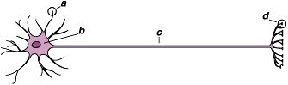

1. Consider the neuron diagram above. Identify the following structures:

a. _______________________ c. _______________________

b. _______________________ d. _______________________

2. Which structure(s) (letters a, b, c, and/or d) is associated with neurotransmitter?

3. In which direction is nerve impulse moving? Right-to-left or left-to-right

**Consider the action potential diagram at the right**:

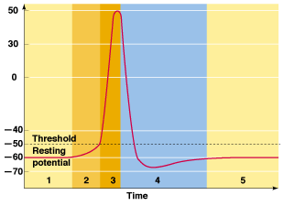

4. Label the following: depolarization phase, repolarization phase, undershoot, hyperpolarization

5. True/False - The sodium/potassium pump is functioning during phase 1 and 2 but not 3 and 4.

6. True/False - Potassium leakage channels are closed during the transmission of an action potential.

7. True/False - Both voltage-regulated gates in the sodium channel are closed in phase 2

8. True/False - the potassium voltage-gate is closed during phase 4.

9. Now, correct any incorrect statements above.

**Consider the diagram of the synapse shown at the right:**

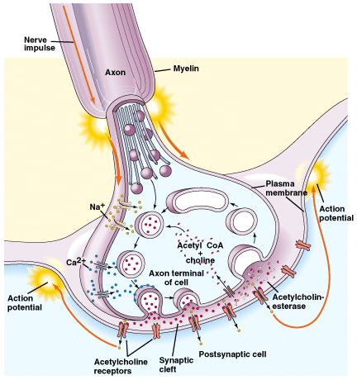

10. True/False - This is an example of an electrical synapse.

11. True/False - Calcium ions enter the pre-synaptic neuron in response to acetylcholine.

12. True/False - Sodium ions enter the post-synaptic neuron in response to an action potential that opens/activates voltage-gated channels

13. True/False - Acetylcholine is the only neurotransmitter found in the nervous system

14. True/False - Acetylcholine is reabsorbed by the neuron to be used again

15. True/False - Vesicles fuse with the pre-synaptic membrane in response to an electrical jolt from the sodium ions

16. Now, correct the false statements.

**Complete the Sentences:**

17. A threshold potential is. . . .

18. A nerve impulse travels in only a single direction because . . .

**Short Answer** *– Answer the following questions using complete sentences*

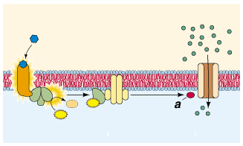

19. What is the diagram at the right showing?

20. What is the function of Schwann cells? Why are they necessary?