Photodecomposition of s-Citalopram (Lexapro®)
Michael Jeffrey Klobes
College of Saint Benedict/Saint John’s University
Ardolf Science Center
Dr. Michael Ross
5-10-05

Abstract
Lexapro®, an antidepressant, contains the biologically active ingredient known as
s-citalopram. S-citalopram was exposed to ultraviolet radiation using a 450 W UV immersion lamp from Ace Glass Incorporated under a formate solution of pH 3, acetate solution of pH 5, ethanolamine solution of pH 9, and a filtered natural water source from Minnesota. The various pH and matrix solutions were made of 10 µM s-citalopram and were exposed to ultraviolet radiation for approximately 96 hours. The relative concentration of s-citalopram was analyzed over the course of ultraviolet bombardment using a Thermo Finnigan LC-MS. S-citalopram was found to have an absence of direct and indirect photolysis occurring in any of the solutions previously mentioned.

Introduction
The pharmaceutical industry has become a booming industry in recent years, and many of the drugs it markets are synthesized chemicals. Lexapro®, is a common antidepressant marketed in the United States with an active ingredient of s-citalopram, shown in Figure 1.³

Figure #1: S-citalopram chemical structure.

Environmental science is becoming a growing field as pollution, the greenhouse effect, and other environmental concerns have raised public concern. Synthesized pharmaceuticals have also raised increasing concern in recent times as recent studies found measurable levels of common drugs, such as aspirin, in streams and rivers.² The pathways in which pharmaceuticals may enter the environment are many and extensive, as seen in Figure #2.

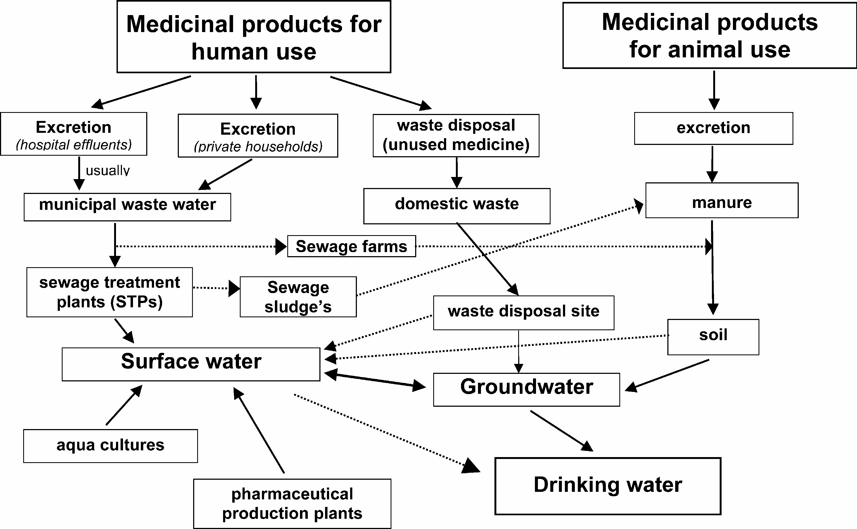
Figure #2: Possible methods of pharmaceutical introduction into the natural water sources of the environment.¹

As seen in Figure #2, many pathways are available for a pharmaceutical drug to enter the environment. All of these pathways listed lead to a water source of some kind, and eventually lead to a human supply of drinking water. When these drugs enter the environment, the biological effects to animals and the ecosystem are often unknown.² One may hypothesize, however, the unwanted effects many of these drugs may pose on the environment, with toxicity being the primary concern, both to humans and the environment. At the moment, however, there is little concern for the severity of effects in the environment as the concentrations of these drugs are found in such small amounts.²

Lexapro® contains only 10 milligrams of s-citalopram, the chemically active antidepressant ingredient. It is a very powerful antidepressant which only requires one small dose a day in most patients.³ Concern is raised with this drug because of its small doses required in a human body. With such small doses required for a larger being, one may hypothesize about what enhanced effects a smaller animal may experience when exposed to the drug. For example, only 10 mg are required for a human dose, what effects would this same dose do to a two pound fish? This dose may be appropriate for a human subject, but for other creatures of less mass, the toxicity or effects of the drug may be greatly enhanced.

Many of the other concerns also deal with the unknown effects which may arise when pharmaceuticals encounter the environment. These drugs bind with specific receptors in humans, but what happens when an amphibian or a reptile come in contact with the drug? These different species may have different receptors to which the pharmaceuticals may bind causing different unwanted effects than seen in human subjects. Along with the unpredictability of the effects the pharmaceutical directly produces there are also its metabolites which call for concern.² These pharmaceuticals may react to produce other analytes which may be reactive in the environment as well.

In the natural world the non-chemical pathway to the degradation of most chemicals is sourced from the sun, or ultraviolet radiation. The degradation of chemicals may be caused by direct or indirect photolysis from the ultraviolet radiation of the sun. During direct photolysis the ultraviolet radiation directly interacts with the substrate and cause the substrate to break down into different analytes. Indirect photolysis occurs when the substrate does not directly interact with ultraviolet radiation, but is degraded by a neighboring specie which initiated by ultraviolet radiation.

A simulation of photolysis in nature may be achieved by exposing the chemical to direct ultraviolet radiation in the laboratory. With the use of various solution environments the pH dependency, along with the presence or absence of direct and indirect photolysis, of a chemical’s resistance to ultraviolet degradation can be determined. This particular experiment used the control of an ultraviolet source, different pH environments, and a natural water source to determine the result of photochemical degradation over time.

Experimental

Isolation of s-Citalopram
S-citalopram was isolated in pure form from Lexapro® tablets using chloroform as an organic solvent and mass spectrometry as a characterization confirmation tool. As advertised, Lexapro® tablets contain approximately ten milligrams of s-citalopram. Using a mortar and pistol, one tablet was ground to a fine powder. The s-citalopram was isolated with an extraction using chloroform. A formic acid solution of pH 3 was used to extract the s-citalopram from the organic chloroform solvent. Solution was found to have an approximate molarity of 61.54 µM after dilution into 500 mL of a pH 3 formic acid solution, which was then stored in a dark glass bottle to prevent decomposition. The presence of s-citalopram was confirmed by mass spectrometry.

LC-MS Method
A method was found to quantitate relative concentrations using a liquid chromatography mass spectrometer. The stationary phase used for chromatography was a Synergi 4u MAX-RP 80A 150 x 3.0 mm 4 micron column. The s-citalopram was found to exit the column with a 1.60 minute retention time using a 60:40 acetone:pH 3 formate mobile phase. The formate buffer was made using 10 mL concentrated formic acid, 1.8 mL ammonium oxide, and diluting to 500 mL. The quantitative results were characterized using the PDA of the LC-MS.

Photolysis
Approximately 10 µM solutions of s-citalopram were produced in different pH solutions along with a natural water source. The solutions used for photolysis were pH 3 formate solutions, pH 5 acetate solution, pH 9 ethanolamine solution, and a filtered East Gemini Lake water solution, which was located on Saint John’s University campus in Collegeville, MN. All solutions were placed in a photoreactor equipped with a 450 W UV immersion lamp from Ace Glass Incorporated. The solutions were exposed to ultraviolet radiation for approximately 96 hours while aliquots were taken at various times, and removed from direct exposure to the ultraviolet radiation. The LC-MS method was then used to quantitate the relative photodegradation s-citalopram over time.

Results/Discussion
Figure #3: Photolysis of s-citalopram in a formate pH 3 solution for
approximately 80 hours using a 450 W UV immersion lamp as the source
of ultraviolet radiation.

Figure #3 shows s-citalopram at pH 3 under photolysis for approximately 80 hours. A linear regression was established with an R-squared value of 0.0026.
Figure #4: Photolysis of s-citalopram in an acetate pH 5 solution for
approximately 80 hours using a 450 W UV immersion lamp as the source
of ultraviolet radiation.

Figure #4 shows s-citalopram at pH 5 under photolysis for approximately 80 hours. A linear regression was established with an R-squared value of 0.00008.

Figure #5: Photolysis of s-citalopram in an ethanolamine pH 5 solution for
approximately 80 hours using a 450 W UV immersion lamp as the source
of ultraviolet radiation.

Figure #5 shows s-citalopram at pH 9 under photolysis for approximately 80 hours. A linear regression was established with an R-squared value of 0.0434.

Figure #6: Photolysis of s-citalopram in a natural water source( from East
Gemini Lake located on Saint John’s University campus in Collegeville, MN)
for approximately 80 hours using a 450 W UV immersion lamp as the source
of ultraviolet radiation.

Figure #6 shows s-citalopram in East Gemini Lake water under photolysis for approximately 80 hours. A linear regression was established with an R-squared value of 0.00672.

Figures #3 through #6 showed that the relative abundance of s-citalopram did not decompose significantly during the 80 hours of exposure to ultraviolet light under the various conditions. There was actually an increase in abundance in Figures #3, #5, and #6 as shown from the linear trend line drafted from the plotted points. This observation, however, was gathered most likely from error in the experiment.

As seen in all figures the deviation of the plotted points varied throughout the experiment. This error is most likely due to systematic errors in collecting data. By omitting the extreme data points the deviation throughout the experiment was seen to decrease. The retention time of s-citalopram was seen to only last approximately 1.60 minutes which lead to a relatively short-times chromatogram. This may have effected the observed widths of the peaks and created error in calculating the areas of the PDA peaks.

The various pH solutions seen in Figures #3 through #5 showed the absence of direct photolysis degradation of s-citalopram. These solutions contained no other species except the relative buffers, water, and s-citalopram leaving only ultraviolet light to react directly with s-citalopram. Due to the abundance of s-citalopram after 80 hours of exposure to direct ultraviolet radiation, s-citalopram was found to be unaffected by direct photolysis.

East Gemini Lake was used to test the possible effects of indirect, as well as direct, photolysis. As the lake water was a natural source, or simulated a natural body of water, there may have been contained in the solution other species which may have reacted with s-citalopram as a result of indirect photolysis. Again, after 80 hours of exposure to ultraviolet radiation s-citalopram was left unaffected in relative concentration throughout experimentation.

Lexapro® is known to have few side effects in human subjects, and it requires small doses for the desired physiological effects it produces.³ The findings may help explain these observations, as it was left relatively unaffected after direct ultraviolet radiation exposure. It may be that the active ingredient in Lexapro®, s-citalopram, may be very receptor specific in the body and reacts with few other species present in the environment.

Conclusion

S-citalopram was found unreactive under direct and indirect photochemical degradation under solutions of pH 3, pH 5, pH 9, and a natural lake water solution. Due to its unreactivity in the laboratory environment, Lexapro® may pose as a potential pollutant to the ecosystems. Thus far the affects of Lexapro® on other subjects, such as fish, bacteria, and other marine life, has not been studied in great detail. The affects may or may not be a serious threat to the environment, however, further research is required to find the effects of the pharmaceutical as it is now known to be present in aquatic environments through the mechanisms seen in Figure #2.

References

1. Heberer, Thomas. “Occurrence, Fate, and Removal of Pharmaceutical Residues in the Aquatic Environment: a Review of Recent Research Data.” in Toxicology Letters. 131(1-2), pp. 5-17, 2002

2. Jones, O.A.H., Lester, J.N., Voulvoulis, N. “Potential Ecological and Human Health Risks Associated with the Presence of Pharmaceutically Active Compounds in the Aquatic Environment.” in Critical Reviews in Toxicology. 34(4), pp.335-350, 2004

3. Lexapro® Information Website. http://www.lexapro.com/

4. Atta-Politou, Julia, Panderi, Irene, Constantino, Pistos. “Liquid Chromatography-Positive Ion Electrospray Mass Spectrometry Method for the Quantification of Citalopram in Human Plasmas.” in Journal of Chromatography, B: Analytical Technologies in the Biomedical and Life Sciences. 810(2), pp.235-244, 2004

5. Lemmer, Bjoern, Wang, Ning Shen. “Determination of Citalopram in Plasma and Brain Tissue of the Rat by High-Performance Liquid Chromatography with Ultraviolet Detection.” in Journal of Chromatography. 488(2), pp.492-497, 1989

6. “Preparation of Pure Citalopram.” US Patent: US6781003

7. Harris, Daniel C. Quantitative Chemical Analysis, 6th Ed. (New York: W.H. Freeman and Company, 2003)

