Phosphate Concentration Determination of the Watab River Shed

Stephen J. Lasslo, Eric A. Moldestad, and Dr. Michael Ross*

Department of Chemistry

Saint John’s University/College of Saint Benedict

St. Joseph, MN 56374

Water samples were gathered from various sites on and surrounding the Saint John’s campus each week during the summer of 2001. These samples were then tested using two different methods of phosphate concentration determination. The primary reason for testing the phosphate levels was to determine the impact of the Saint John’s sewage treatment plant (which dumps into East Gemini Lake) on the surrounding water system. The study found that phosphate levels at East Gemini Lake (and the sites downstream of East Gemini Lake) were below one part per million as recommended by the Environmental Protection Agency for sewage effluent.⁵ Each of the remaining sites had phosphate levels considerably lower than one ppm.

Introduction
The purpose of this experiment was to monitor the concentration of phosphate in the water system of the Watab River Shed. Phosphate is an essential nutrient for algae growth and in most unpolluted waters, phosphate is the limiting growth nutrient. Therefore, if the phosphate concentrations in a water system are elevated then increased algae growth can occur. Excessive algae growth can lead to eutrophication or rapid aging of a lake. This occurs when the lake prematurely fills, as large amounts of algae die and sink to the bottom of the lake building layer upon layer, eventually filling in the lake. The Saint John’s sewage treatment plant dumps directly into East Gemini Lake and thus the possibility of eutrophication is of great concern. In order to determine the impact of the Saint John’s sewage treatment plant on the Watab River System, water samples were gathered from selected sites and two methods of phosphate concentration determination were used to monitor the phosphate levels.

Background
One of the methods that can be used to determine the concentration of phosphate in solution is capillary electrophoresis. Shown below (Figure 1) is a typical schematic of a capillary electrophoresis instrument.
Figure 1.¹
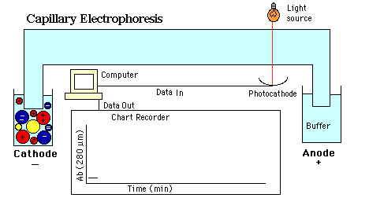

Electrophoresis is the migration of charged particles within a solution in response to an applied voltage potential. Capillary electrophoresis employs the use of a capillary generally 25-100 cm in length and 50-75 micrometers in inner diameter. The potential applied across this capillary is typically 10-30 thousand volts.¹ The species of interest is injected into the capillary (at the anode if the species is positively charged, at the cathode if the species is negatively charged) and the absorbance of the solution is then monitored as time progresses. The migration time of each ion is determined by its charge to size ratio, with the smallest most highly charged ions migrating fastest, and the larger less charged species migrating at a slower rate. The typical migration times of various ions can be seen below in Figure 2.
Figure 2.²
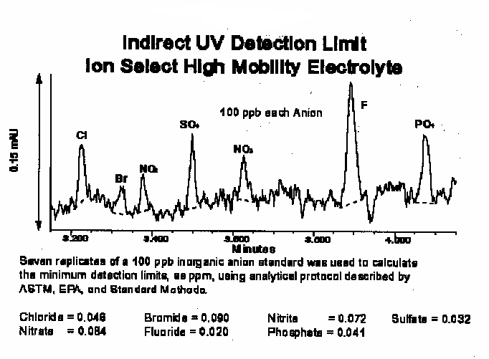

If the species of interest absorbs then an increase in absorbance seen in the absorbance spectrum is directly related to an increase in the concentration of that species in solution. However, if the species of interest does not absorb then an indirect method of measuring absorbance must be employed. Indirectly monitoring the absorbance of a species can be accomplished by using a buffer system that absorbs and then observing the decrease in absorbance as the species of interest passes the detector.

Experimental
Classical Phosphate Method
Tin II chloride procedure:
- 50 mls of phosphate standard/sample was pippeted into a 125 ml erlenmyer flask.
- 2 mls of ammonium molybdate reagent was added to the 125 ml flask.
- 0.5 mls of Tin II chloride solution was added to the 125 ml flask.
- Solution was mixed for 5 minutes and UV-vis absorbance spectrum was then taken at 720 nm.
- Steps 1- 4 were repeated, with the solutions being filtered using Hirsch filtration before the UV-vis absorbance spectrum was then taken.

Ascorbic acid procedure:
- 6 mls of phosphate standard/sample was pippeted into a test tube.
- 2 mls of working solution was pipetted into test tube.
- Solution was immediately vortexed for 30 seconds and then allowed to react for 15 minutes, UV-vis absorbance spectrum was then taken at 720 nm.

Capillary Electrophoresis Procedure
- A chromate buffer solution was constructed
- The capillary was filled with the chromate buffer.
- Phosphate standard was injected into the capillary by immersing the cathodic end of the capillary in a reservoir containing the phosphate standard and elevating the reservoir for ten seconds.
- The detector was set at 360 nm and the absorbance spectrum was plotted vs. time.
Results/Discussion
In this experiment silica capillaries of different diameters were used ranging from 50-250 micros. The voltage potential applied across the capillary was 10 kV. A chromate buffer system was used to allow for indirect absorption of phosphate. The detector was set at 360 nm, the wavelength at which the chromate solution most strongly absorbs. Several problems were encountered while trying to construct a properly functioning capillary electrophoresis instrument. One of the most pressing problems was lining up the light source and the detector. The capillary runs perpendicular to the light source and the detector, and must run directly between the two. If the capillary is not sandwiched properly between the light source and the detector, a decrease in absorbance is observed. The silica capillary is sheathed with a protective coating, which provides the capillary greater flexibility and durability. The protective coating must be removed to provide a window for the light source to shine through. However, once the protective coating is removed the capillary becomes extremely brittle and therefore positioning the capillary between the light source and detector without breaking the capillary becomes extremely difficult. Once the capillary is properly positioned between the light source and detector it must be held stationary, since movement of the capillary will result in fluctuations of absorbance readings.
With the capillary properly positioned a sample was injected at the cathode using a siphoning method. The sample is injected by dipping the capillary in the sample reservoir and then elevating the reservoir for ten seconds. Once the sample has been injected into the capillary the absorbance of the solution is plotted vs. time as seen in Figure 3. The plot provided in Figure 3, was obtained from a run using concentrated standard. The results seen in Figure 3 are in accordance with theoretical expectations, however the behavior observed in Figure 3 could not be reproduce. The absorbance of the solution vs. time is shown in blue. As time progresses this absorbance is seen to remain relatively constant due to the constant presence of the chromate solution in the capillary absorbing the light from the light source. However, a large decrease in the absorbance is observed at point 1 in Figure 3. This decrease in absorbance is due to a plug of phosphate ion migrating through the capillary and passing between the light source and the detector. The plug of phosphate ion, which does not absorb, displaces the chromate solution which does absorb, thus the decrease in absorbance is observed at point 1. The absorbance of the chromate solution vs. wavelength is seen in red. The absorbance of the chromate solution can be seen to absorb most strongly at 360 nm.

Figure 3.
Absorbance vs.time/wavelength

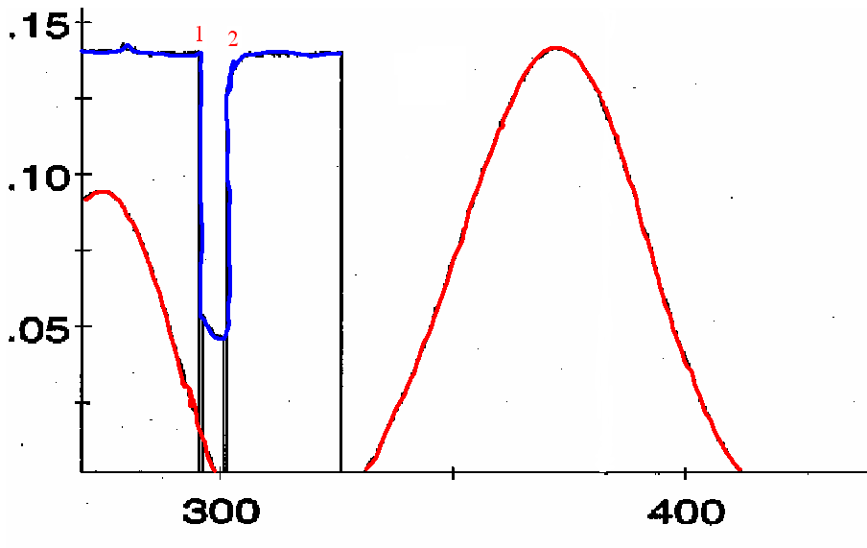
The absorbance vs. time plot seen in Figure 3, is that expected for a phosphate run on the capillary electrophoresis instrument. However, subsequent phosphate standard runs did not produce the decrease in absorbance as seen at point 1. in Figure 3. Instead the absorbance of the following runs yielded a relatively constant level of absorbance as time progressed. As of now the concentration of phosphate in solution cannot be determined using this C.E. instrument, but this project is still a work in progress.
In order to determine the concentration of phosphate in the collected water samples a classical method dependent upon the reduction of a phospho-molybdate complex ((NH4)3PO4·12MoO4
) was used. As seen in the experimental section the two mls of working solution (containing molybdenum and ascorbic acid) was added to six mls of the phosphate sample. Upon addition of the working solution, the molybdenum complexed with the phosphate forming a phospho-molybdate complex. This complex was then reduced using ascorbic acid. Upon reduction of the phospho-molybdate complex the solution became a clear blue. The intensity of the solution was directly related to the concentration of phosphate in solution. A set of phosphate standards was constructed, and the equation obtained from the standards used to determine the phosphate concentrations in the collected water samples. A plot of one of the phosphate standard sets can be seen below in Figure 4.
Figure 4.

The first attempt of obtaining an adequate phosphate standard plot involved the use of tin II chloride as the reducing agent. Using tin II chloride as the reducing agent yielded a turbid solution. In previous experiments an absorbance spectrum was taken exactly five minutes after the addition of the reducing agent.⁴ This precise timing was intended to remove the turbidity factor. However, taking an absorbance spectrum after five minutes did not provide the desired standard plot. The turbidity of the solutions was interfering with the absorbance readings. In order to reduce the turbidity the solutions were filtered using a Hirsch filtration system before the absorbance spectrum was obtained. The results of this filtration process proved inadequate in ridding the solution of turbidity and the method using tin II chloride as the reducing agent discarded.
The method using ascorbic acid as the reducing agent was then employed. Upon reduction of the phospho-molybdate complex by ascorbic acid, the observed solution was a clear blue. The absence of turbidity in these samples allowed for the desired standard plot to be obtained. Thus, the use of ascorbic acid as the reducing agent as outlined in the procedure section was the method used to determine the concentrations of phosphate in all the collected water samples. A plot of the phosphate concentrations for the summer of 2001 from designated collection sites can be seen in Figure 5.
Figure 5.
As seen in Figure 5, all the water collected water samples have phosphate concentrations below 1 ppm. Thus, the concentration of phosphate in the water samples is meets the Environmental Protection Agency standards (E.P.A.) which is less than 1 ppm phosphate for sewage effluent.⁵ According to the E.P.A. the concentration of phosphate in non-polluted waters should be less than 0.1 ppm.⁵ The water samples collected at Lake Sagatagan, Stumpf Lake Exit, and the South Fork, all meet the requirements for non-polluted waters as would be expected. The concentrations of phosphate can be seen to decline from Gemini Exit to Hwy #4. This is expected since the St. John’s sewage treatment plant dumps directly into Lake Gemini and then proceeds to the Wetlands, then on to Collegeville Rd, Hwy 3, Hwy 2, Hwy 4 and finally Sartell. The concentration of phosphate in the water most likely decreases due to dilution by runoff water and other drainage. The phosphate concentration may also decline due to phosphate uptake by plants and algae.

Conclusion
The study found that phosphate levels at East Gemini Lake (and the sites downstream of East Gemini Lake) were below one part per million as recommended by the Environmental Protection Agency for sewage effluent.⁵ Thus, the impact of the Saint John’s sewage treatment plant upon the Watab River system, although noticeable, is within the limits suggested by the E.P.A.

Resources:

1. CE Theory found at http://www.ceandcec.com/cetheory.htm
2. Detection limit time scale http://www.waters.com/waters_website/Applications/cia/ciaapp1.htm
4. O’Neill, Marne. Analysis of Nitrate and Phosphate in the Lakes at St. Johns University: A Study of Three Methods. May 10, 1999
5. Water Quality Monitoring Project: Sources of Phosphorus found at http://www.discoverycube.org/programs/phosphate.htm

