Final Report
Curriculum and Program Development Grant
Upgrade to Capillary Electrophoresis System
Michael Ross
Chemistry Department

April 15, 2001
Project Goals:

- to provide the hardware and software needed to move from a system which requires two computers to control the equipment, to a system where both the spectrophotometer and CE power supply are controlled by one computer system
- provide me a modern programming platform by which I can continue exploring methods of developing instrumental interfaces for older departmental instruments.

Progress to Date:

The LabView Software and two interface cards were purchased in early December. Programming has been done on developing the control for the high voltage power supply. We are now able to control the power supply and acquire spectrophotometric data all with the same computer. I have been able to integrate the two programs to the point where by pressing one button in the power supply program, I can activate the power supply program and also start the spectrophotometer. This therefore makes the timing for the experiment constant from one analytical run to another.
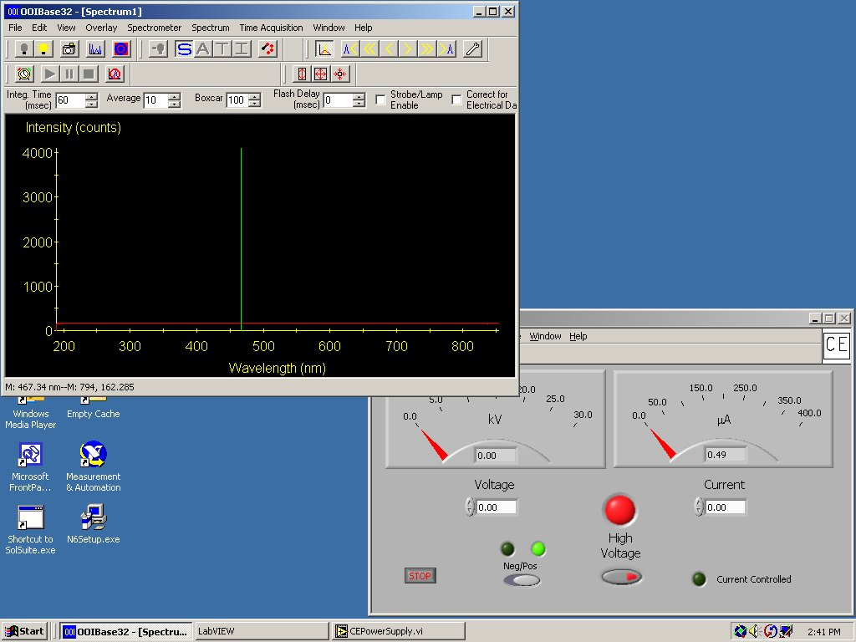

When the High Voltage button is pressed, both the high voltage power supply and the spectrophotometer will start. Since CE is a technique that causes the separation as a function of time, it is very important that both parts of the system start at the same time.

I am becoming more adapt at using LabView – though there is still more to learn than I have time to learn it in. I have also been able to upgrade the computer system for the 10 year old electrochemical system and now have it running on a Windows 2000 based system. This conversion was made much simpler because of an updated interface card purchased with the grant. As I become more facile with LabView, I hope to be able to rewrite the program that drives this instrument so that the instrument is controlled through the LabView environment.

I have also been able to make use of the interface card used by the CE system to rewrite a program which I developed to do potentiometric titrations. This was done just to gain more experience with the programming environment. I doubt that I would ever completely go the the LabView environment for this program since I use the program in one of my classes and converting to the LabView environment would require us to purchase six additional interface cards at $1000 each and six more LabView licenses at $1900 each. The Visual Basic program I currently use does not need the interface card to do the same experiment and can be run on a standard PC with two serial ports.

