Final Report
Curriculum and Program Development Grant
Analysis of Surface Water for Anions and
Pesticides using Capillary Electrophoresis
Michael Ross
Chemistry Department

April 15, 2002
Project Goals:

- Build a Capillary Electrophoresis System from available equipment
- Purchase a Commercial UV-Visible Detector for the CE System
- Develop methods to analyze for nitrate and phosphate in surface water
- Explore the possibility of using the CE system to analyze surface water for pesticides

Progress toward completion:

Let me start by stating that there are a very good reasons that someone will go out and spend $35,000 for a commercial instrument to do capillary electrophoresis, rather than spending $5,000 and build one of their own. Our work during the Summer of 2001 provided us with some of those reasons.

The Ocean Optics Spectrophotometer was ordered in late May and delivered about the middle of June. Before the spectrophotometer arrived, we build a prototype CE system by mounting the capillary and its buffer reservoirs on a piece of plywood. When the spectrophotometer arrived, we mounted the detector part of the spectrophotometer on the plywood, secured our electrodes and began developing our method for analysis. From the literature¹, we were able to find results from another lab group that had successfully analyzed for both nitrate and phosphate using capillary electrophoresis (using a commercial system). We decided that by using their procedure as a base, we could compare our system to their system and improve on their analysis. That is when the real learning began.

Because of its availability, we used a capillary that was 250 uM in diameter. This capillary is a piece of glass, coated with a polyamide coating to prevent breakage. After several weeks of struggle, we found that; 1) the capillary is very fragile without the coating (many broken capillary ends; 2) alignment of the capillary in the detector takes the patience of Solomon; and of most concern was that the capillary was to big in diameter to be able to get the analysis to take place.

We then purchased a small piece of 75 uM capillary ( 75 mM is about the diameter of this line ______ ). If the 250 uM capillary was fragile, this stuff has been impossible. We need to remove the polyamide coating where the capillary passes through the detector, then align the capillary with the spectrophotometer. Needless to say even the patience of Job would be tried.

By the end of July, we finally had the detector and capillary aligned and were ready to start our analysis. Again after weeks of struggle, we found that the plywood has as much conductivity in the hot-humid laboratory as the capillary, and as a result we were not able to perform successful analyses. At that point we set about to build a cabinet to hold the CE detector, electrodes and buffer reservoirs out of plexiglass.

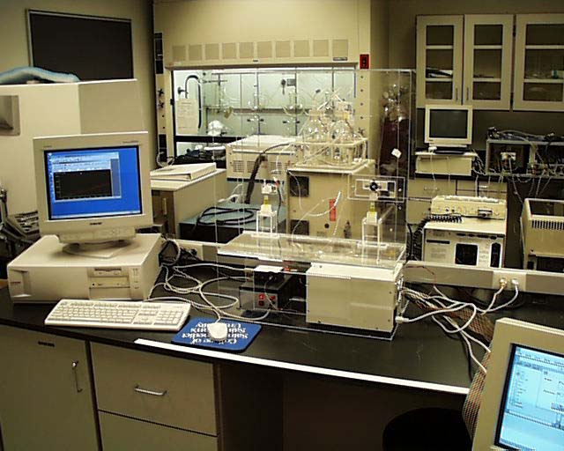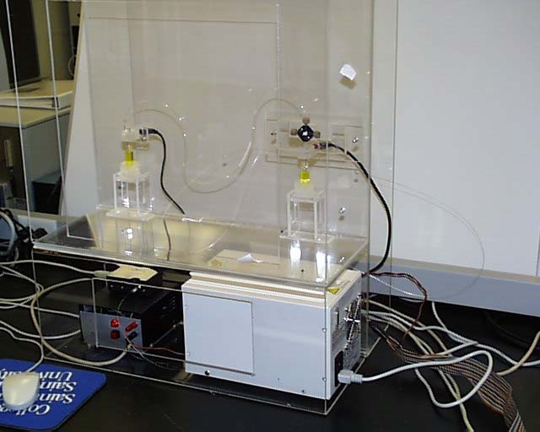

Pictured above is the CE system which was built. The system includes a computer interface/controlled 0-30 kV power supply, a computer controlled UV-
Visible Spectrophotometer and the plexiglass cabinet to house the equipment. The picture on the left shows the two buffer reservoirs (yellow solution) along with the electrodes. This was completed about the end of August, and the summer was over.

During this past academic year, we continued to struggle with the capillary breaking. We have tried a variety of things to get the capillary aligned with the spectrophotometer and have finally at least gotten some data. Below is a CE of a 25 mM solution of nitrate and phosphate. There is a tremendous amount of noise, and therefore our signal/noise ratio is very bad. In order to make the system useful at the 0.1 ppm level, the signal/noise ratio will have to be improved. Current work is looking at trying to decrease the number of reflective surfaces the light must pass through before it gets to the detector. By reducing the number of surfaces, more intensity should be available, more signal will result, and the noise issue should go away.

We will continue to work on the instrument this coming summer as our monitoring of the Watab River through SJU is an ongoing project which is limited without better detectability.

