ECON 111 -01A Dr. John F. Olson
Introduction to Economics Spring 2017
Homework/Problem Set #2 – answers

1. Because bread is a basic and important staple in the diets of the residents of the nation of West Dakota, suppose the government imposes an effective price ceiling of $2 on a loaf of bread. How will consumers and producers each react to this policy and what are the likely consequences in the West Dakota bread market? If loaves of bread cannot be legally sold at prices higher than $2, what other actions may arise or occur?

The effective $2 price ceiling will create a shortage of bread – at this lower price, consumers will increase the quantity demanded, while producers will decrease the quantity supplied. Unsatisfied consumers might look around for substitute baked goods not subject to the price control, such as rolls and buns; producers might shift production towards those substitutes, looking for more profitable products. One could imagine a “black” (illegal) market for bread developing.

2. a. Draw a supply and demand graph of a market, showing the equilibrium price and quantity. Indicate the areas which represent consumer surplus and producer surplus.

In the graph below, CS is the consumer surplus – the area below the demand curve but above the market price, P*; PS is the producer surplus – the area above the supply curve but below the market price, P*.

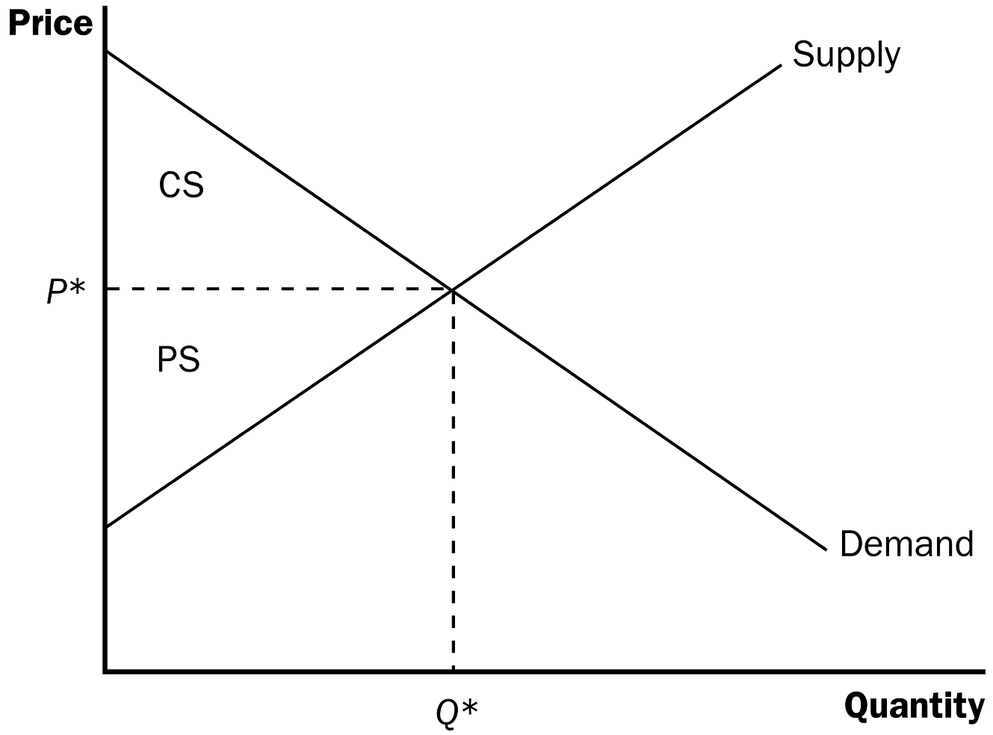

b. Re-draw the supply and demand graph, but now impose a tax (recall or note that it does not matter whether the tax is collected from the buyers or the sellers). Show the price consumers pay, the price sellers receive, and indicate the areas representing consumer surplus, producer surplus, the tax revenue, and the deadweight loss.

In the graph below, P_{B} is the price consumers pay, P_{S} is price sellers receive – the difference is the tax. Area A is the consumer surplus, area F is the producer surplus, the tax revenue is the areas of B+D (the quantity Q₂ x the tax P_{B}-P_{S}), and the deadweight loss is the areas of C+E.
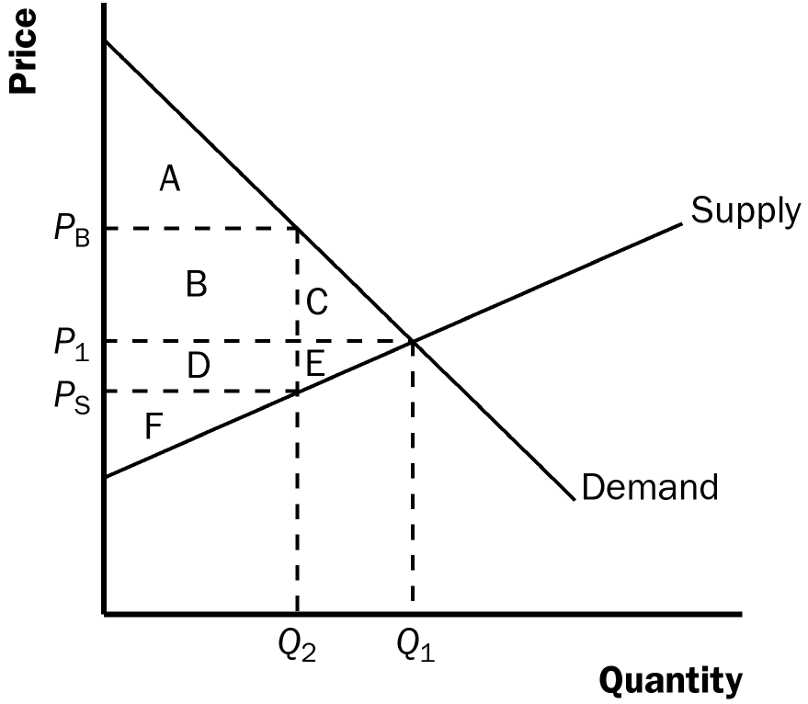

3. You have secured a summer internship with your local government. To cover rising budget costs, the governing council is considering a 10% increase in the fee (a tax) charged to households for the weekly local curb-side trash and recycling collection. You are asked for an economic analysis of the likely short-run and long-run effects of this action and to make a recommendation to the council. What would you recommend and why?

There are several things you could consider and discuss in your analysis. One is that the demand curve for this service is likely to be relatively inelastic – and more inelastic in the short-run than in the long-run. Thus, the incidence or burden of the higher fee will fall mostly (more heavily) on households. As well, the higher fee will generate more revenue – so it could be an effective way to raise funds for the budget. Households have fewer alternatives or options in disposing of their waste and recyclables, but some households might in the long-run search for less expensive alternatives (and terminate their use of the service) – they might consider illicit dumping or trash burning, using other recycling services, or other alternatives to disposing trash and/or recyclables. And the deadweight loss created by the higher fee is likely to be small – so total social welfare is not reduced very much.

4. When an externality is present in some activity, possible solutions include imposing corrective (Pigovian) taxes or subsidies, tradeable permits, use of command-and-control (regulations or rules), or resorting to private solutions by application of the Coase Theorem (assignment of private property rights). How and why (or why not) are these employed as solutions in the following situations:
a. some students in your residence hall want to play loud music at any time of the day or night
b. compared to passenger cars, heavy trucks impose more wear and tear on roads and highways
c. rainfall washes fertilizer from farm fields and residential lawns into the watershed, producing toxic blue-green algae blooms which make local lakes unfit and unsafe for recreational use (fish kills, bad odor, and hazardous to skin contact)

This question and the different situations are intended more towards to have you think about how one might address different sorts of externalities with different approaches or policies.

a. A “command-and-control” approach of having (and enforcing) “quiet-hour” rules is probably more efficient and effective than trying alternative methods to address these sorts of externalities. Imposing and collecting a “music” or “noise” tax could prove cumbersome; trying to negotiate contractual agreements among all the floor residents would have high transactions costs.

b. Heavy trucks do pay higher registration and license fees than passenger cars, as well as fuel taxes – that is, we do impose “corrective” (or Pigovian) taxes to address this externality. But one could ask or question whether or not those are high enough to internalize the full externality they create. You might note that some roads have maximum-allowable weight restrictions imposed (and enforced) – especially during the spring “thaw” season when the ground underneath those roads is unstable and the heavier vehicles would do more damage.

c. This is a problem in some MN communities (for example, Little Rock Lake, about 10 miles northeast of the St. Cloud area). Possible solutions might be imposing corrective (Pigovian) taxes on fertilizer sales or rules/regulations about fertilizer use (not likely to popular with the farmers or people who want green lawns, though). Tradeable fertilizing permits – interesting idea, but again not likely to be popular. Given the large number of involved or affected parties – farmers, homeowners, lake users – there would be high transactions costs to negotiate a private solution.

5. Nimbus, Inc. makes brooms and then sells them door-to-door. The following table shows the relationship between the number of workers and Nimbus’ output in a given day.
a. Fill-in the column of marginal products. What pattern do you see and how might you explain it?
b. The firm has fixed costs of $200 and a worker costs $100 a day. Use this information to fill in the column for total cost.
c. Fill-in the column for average total cost (ATC = TC/Q). What pattern do you see?
d. Fill-in the column for marginal cost (MC = ΔTC/ΔQ). What pattern do you see?
e. Compare the columns for marginal product and marginal cost. Explain the relationship.
f. Compare the columns for average total cost and marginal cost. Explain the relationship.

a. Below is the completed table. Marginal product rises at first, then declines because of diminishing marginal product.

Workers Output Marginal Product Total Cost Average Total Cost Marginal Cost
0 0 --- $200 --- ---
1 20 20 300 $15.00 $ 5.00
2 50 30 400 8.00 3.33
3 90 40 500 5.56 2.50
4 120 30 600 5.00 3.33
5 140 20 700 5.00 5.00
6 150 10 800 5.33 10.00
7 155 5 900 5.81 20.00

b. See the table for total cost.

c. See the table for average total cost. Average total cost is U-shaped. When quantity is low, average total cost declines as quantity rises; when quantity is high, average total cost rises as quantity rises.

d. See the table for marginal cost. Marginal cost is also U-shaped, but rises steeply as output increases. This is due to diminishing marginal product.

e. When marginal product is rising, marginal cost is falling, and vice versa.

f. When marginal cost is less than average total cost, average total cost is falling; the cost of the last unit produced pulls the average down. When marginal cost is greater than average total cost, average total cost is rising; the cost of the last unit produced pushes the average up.

6. Jane’s Juice Bar has the following cost schedule (below):
a. Calculate average variable cost (AVC), average total cost (ATC), and marginal cost (MC) for each quantity.
b. Graph all three curves (AVC, ATC, and MC) in a single diagram. What are the relationships between the AVC and ATC curves, the MC and AVC curves, and the MC and ATC curves? Explain.

a. The completed table below shows average variable cost (AVC), average total cost (ATC), and marginal cost (MC) for each quantity.

Quantity Variable Cost Total Cost AVC ATC MC
0 $0.00 $30.00 --- --- ---
1 10.00 40.00 $10.00 $40.00 $10.00
2 25.00 55.00 12.50 27.50 15.00
3 45.00 75.00 15.00 25.00 20.00
4 70.00 100.00 17.50 25.00 25.00
5 100.00 130.00 20.00 26.00 30.00
6 135.00 165.00 22.50 27.50 35.00

b. The graph below shows the three curves. The marginal-cost curve is below the average-total-cost curve when output is less than four and average total cost is declining. The marginal-cost curve is above the average-total-cost curve when output is above four and average total cost is rising. The marginal-cost curve lies above the average-variable-cost curve.

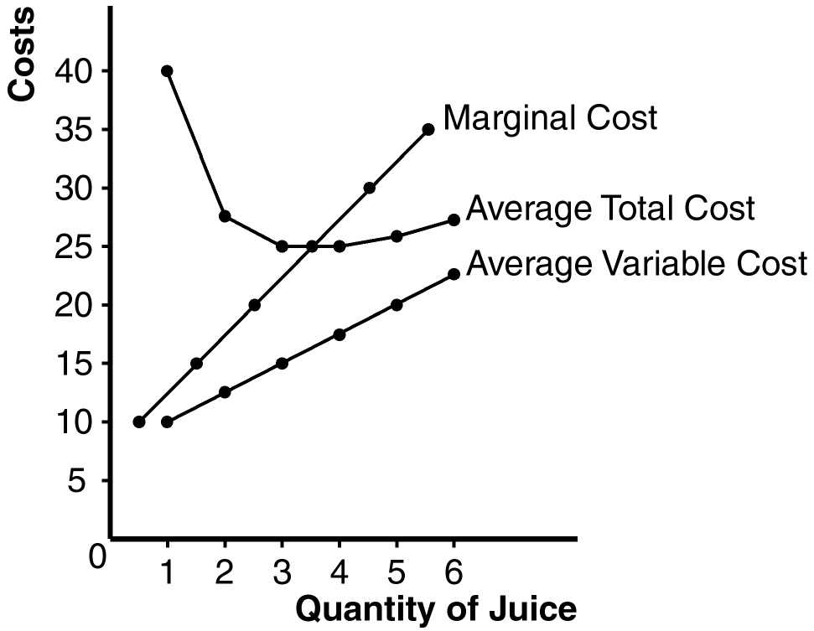

7. Consider the following table of long-run total costs for three different firms:

Quantity = 1 2 3 4 5 6 7____
Firm A $60 $70 $80 $90 $100 $110 $120
Firm B 11 24 39 56 75 96 119
Firm C 21 34 49 66 85 106 129

Does each of these firms experience economies of scale or diseconomies of scale?

The table below shows quantity (Q), total cost (TC), and average total cost (ATC) for the three firms:
Firm A Firm B Firm C
Quantity TC ATC TC ATC TC ATC
1 $60.00 $60.00 $11.00 $11.00 $21.00 $21.00
2 70.00 35.00 24.00 12.00 34.00 17.00
3 80.00 26.67 39.00 13.00 49.00 16.33
4 90.00 22.50 56.00 14.00 66.00 16.50
5 100.00 20.00 75.00 15.00 85.00 17.00
6 110.00 18.33 96.00 16.00 106.00 17.67
7 120.00 17.14 119.00 17.00 129.00 18.43

Firm A has economies of scale because average total cost declines as output increases. Firm B has diseconomies of scale because average total cost rises as output rises. Firm C has economies of scale from one to three units of output and diseconomies of scale for levels of output beyond three units.

