ECON 111 -01A Dr. John F. Olson
Introduction to Economics Spring 2017
Answers to Homework/Problem Set #1

1. Describe an incentive (positive or negative) your parents have offered to you in an effort to influence your behavior.

Responses will vary from student-to-student. Positive incentives, such as money payments or other rewards for doing some task or accomplishment, provide a benefit to behave. Negative incentives (disincentives), such as a punishment or loss of a privilege, increase the cost of misbehaving (and, thus, encourages appropriate behavior).

2. How do prices serve as an “invisible hand” in markets to guide people to make the “best” decisions for themselves?

Prices, in reflecting opportunity costs, provide incentives to buy (and consume) and sell (and produce). If people are being rational economic decision-makers (trying to make the best decisions for themselves), then they will choose to do things where the expected benefits exceed or are at least equal to the opportunity costs. Thus in markets, consumers will buy goods up to the amount where the last unit purchased equals the price paid; producers/sellers will offer goods up to the amount where the price received equals their cost of producing/selling (to maximize their profit).

3. Explain the two main causes for market failure and give a concrete (illustrative) example of each.

Market failure can occur because of: 1) an externality (when actions of a person affect the well-being of a bystander by imposing costs or benefits on the bystander) or 2) the presence of market power (when a market participant can affect/influence the market price). Examples should illustrate each of these.

4. a. Draw and explain a production-possibilities frontier (ppf) for an economy that produces apples and eggs.

There should be a well-labelled graph of a ppf, similar to those shown in the text, showing the production of apples and eggs. It can be a straight-line or bowed/curved ppf, depending on whether the opportunity costs are constant or increasing.

b. What do points outside the ppf represent?

Points outside the ppf represent unattainable combinations of apples and eggs – these amounts cannot both be produced.

c. What do points inside the ppf represent?

Points inside the ppf reflect combinations where either resources are not fully employed or are being inefficiently used or both; that is, more of either/both apples and eggs could be produced.

d. What do the points on the ppf represent?

They represent full-employment and efficient use of resources to produce these combinations of apples and eggs.

e. At any point on the ppf, what does the slope of the ppf represent?

The slope of the ppf at any point represents the opportunity cost – that is the trade-off of getting more apples (eggs) and less eggs (apples)

f. Suppose improved feeding practices increases the hens’ egg-laying productivity – what happens to the ppf? (Show the new ppf.)

With this productivity improvement, the maximum quantity of egg production increases, while there is no change in the maximum amount of apples that can be produced; so the new ppf will be rotated/shifted outward along the egg-axis, but unchanged on the apple-axis.

g. What happens to the original ppf if disease kills half of the hens? (Show the new ppf.)

With the loss of half the economy’s hens, the new ppf reduces maximum egg production by half, while there should be no change in the maximum amount of apples that can be produced; so the new ppf will be rotated/shifted inwards along the egg-axis, but unchanged on the apple-axis.

5. What is the difference between a “change in demand” and a “change in quantity demanded”? How are these each presented or shown in a graph of a demand curve? Similarly, what is the difference between a “change in supply” and a “change in quantity supplied”? How are these each presented or shown in a graph of a supply curve?

A “change in demand” refers to a shift of the demand curve, while a “change in quantity demanded” refers to a movement along a given demand curve. A demand curve displays the various quantities demanded at different prices, holding other things constant (ceteris paribus) such as income, the number of buyers in the market, the prices of related goods, and other non-price factors or variables which affect demand. A “change in demand” shifts the demand curve when any of those non-price factors or variables change, affecting the buyers’ behavior. When those non-price factors or variables are held constant and the price of the good or service changes, then there will be a “change in quantity demanded” with a movement along the demand curve.

The same reasoning/explanation holds for supply. A “change in supply” refers to a shift of the supply curve due to changes in non-price factors or variables affecting sellers’ behavior, while a “change in quantity supplied” is a movement along the supply curve as the price changes, holding other things constant.

6. Consider the demand curve for hamburgers sold in local area food establishments (restaurants, bars & grills, fast-food outlets, etc.). For each of the following events, what happens to that demand curve and briefly explain why:
a. the price of tacos sold in local area food establishments decreases

The demand for hamburgers decreases (shifts left) because tacos are a substitute for hamburgers; with a lower price of tacos, people would eat more tacos and fewer hamburgers.

b. the price of french fries sold in local area food establishments increases

The demand for hamburgers decreases (shifts left) because french fries are complements to hamburgers; with french fries more expensive, people would eat less of them and, accordingly, fewer hamburgers with them.

c. if hamburgers are an income-normal good, incomes in the local area rise in an economic recovery

In this case, the demand for hamburgers increases (shifts right) as income rises.

d. if hamburgers are an income-inferior good, incomes in the local area fall in an economic recession

In this case, the demand for hamburgers increases (shifts right) as incomes fall.

e. local health officials report that they have found some samples of area beef products are contaminated with illness-causing e. coli bacteria

The demand for hamburgers would decrease (shift left); such a report would reduce hamburger buyers’ “tastes and preferences” (they want to avoid illness and possible death).

7. Now consider the supply curve for hamburgers sold in local area food establishments (restaurants, bars & grills, fast-food outlets, etc.). For each of the following events, what happens to that supply curve and briefly explain why:
a. the price of hamburger buns decreases

The supply of hamburgers increases (shifts right) because hamburgers are sold with/on buns.

b. wages paid to food establishment workers increase

The supply of hamburgers decreases (shifts left) because of higher labor (input) costs.

c. the price of hot dogs decreases

The supply of hamburgers increases (shifts right). Hot dogs are an alternative to producing and selling hamburgers for these food establishments; the lower price makes selling hot dogs less attractive to selling hamburgers.

8. Consider the market for minivans. For each of the following events listed below, identify which of the determinants of demand or supply are affected – indicate whether demand or supply increases or decreases, explaining the effect on the equilibrium price and quantity of minivans.
a. people decide to have more children

This increases the number of buyers of minivans, so the demand increases (shifts to the right). No change in the supply curve. The equilibrium price and quantity both increase.

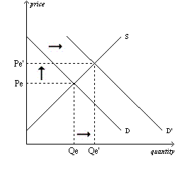
b. a strike by steelworkers raises steel prices

This increases the input costs of producing minivans, so the supply decreases (shifts to the left). No change in the demand curve. The equilibrium price rises and the equilibrium quantity decreases.

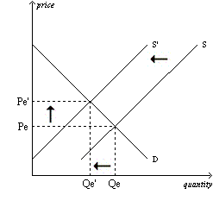

c. engineers develop new automated robot machinery for the production of minivans

This is an improvement in technology which increases the supply (shifts to the right). No change in the demand curve. The equilibrium price decreases and the equilibrium quantity increases.

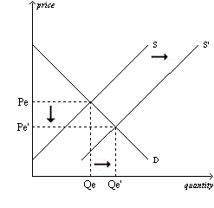

d. the price of sports utility vehicles rises

If sports utility vehicles are substitutes for minivans, then this is an increase in the price of a substitute good, and the demand for minivans increases, which increases the equilibrium price and quantity of minivans. The increase price of sports utility vehicles could induce firms to increase production of sport utility vehicles and reduce their production (supply) of minivans – shifting the supply of minivans to the left – which would increase the equilibrium price and reduce the equilibrium quantity of minivans.
Or one could combine the two graphs – in the case of demand increasing and supply decreasing, the equilibrium price will unambiguously increase, while the change in equilibrium quantity will be ambiguous (either slightly increasing, decreasing, or staying the same).

e. a stock market crash lowers people’s wealth

With the stock market lowering people’s wealth, this decreases the demand for minivans (shifts to the left). With no change in the supply curve, the equilibrium price and quantity both decrease.

9. Consider the market for coffee beans as shown in the demand and supply graph below.
a. what are the equilibrium price and quantity?

The supply and demand curves intersect at a price of $1.00 and 10 (billions of pounds); that is, at that price, the quantity demanded equals the quantity supplied.

b. suppose the market price was $1.50 per pound; what condition would exist in the market? What would happen to the market price in this situation?

At that price, the quantity demanded is less than the quantity supplied – there would be an excess supply or a surplus. In such circumstances, the price would fall.

c. suppose the market price was $0.75 per pound; what condition would exist in the market? What would happen to the market price in this situation?

At that price, the quantity demanded is more than the quantity supplied – there would be an excess demand or a shortage. In such circumstances, the price would rise.

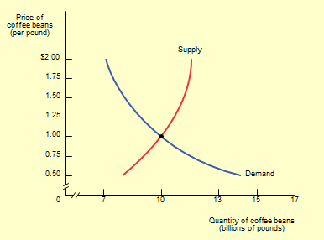

10. Consider this data on the demand and supply schedules for the lobster market:

Price of Lobster Quantity of Lobster Quantity of Lobster New Quantity
(per pound) Demanded (pounds) Supplied (pounds) Demanded (lbs.)
$35 200 1400 600
30 400 1200 800
25 600 1000 1000
20 800 800 1200
15 1000 600 1400
10 1200 400 1600
5 1400 200 1800

- Construct a well-labeled graph, plotting the demand and supply curves.

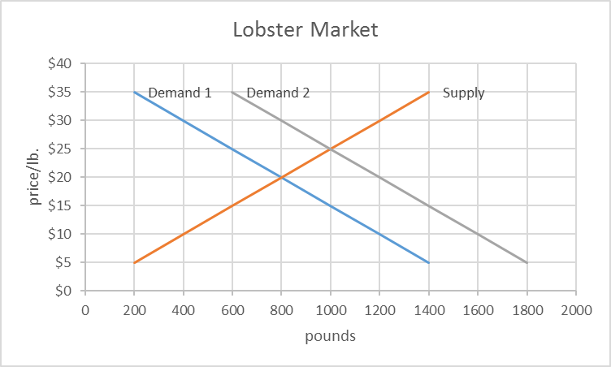

- What are the equilibrium price and quantity, verifying the results are identical in the schedules and graph?

The equilibrium price is $20 and quantity is 800 pounds. This can be verified in the table above (Q^{s}=Q^{d}=800 pounds at $10) and in the graph where the demand and supply curves intersect at those values.

c. Now suppose that incomes rise (lobster is an income-normal good) and the demand for lobster increases by 400 pounds at each price. Plot and label the new demand curve on your original graph. What is the new equilibrium price and quantity?

With the demand schedule/curve shifted to the right by 400 pounds, the new equilibrium price is $25 and quantity is 1000 pounds.

11. Suppose that the demand curve for a good is expressed as Q^{D} = 1600 – 300*P and the supply curve as Q^{S} = 1400 + 700*P.
a. Find the algebraic numerical solution for P where Q^{D} = Q^{S}. At that value of P, show that Q^{D} is numerically equal to Q^{S}.

With the demand curve as Q^{D} = 1600 – 300*P and the supply curve as Q^{S} = 1400 + 700*P, we have two equations with two unknowns (P and Q). In equilibrium, Q^{D} = Q^{S}, so we can substitute. We then have 1600 – 300*P = 1400 + 700*P. Solving for P, we find P = $0.20. Substituting that into each of the demand and supply equations, Q^{D} and Q^{S} are each equal to 1540.

b. For values of P from $0.05 to $0.30 in 5-cent increments, prepare a table showing the demand and supply schedules. Then graph the demand and supply curves. Verify that your answers in “a” are also the same as those shown your table and in the graph.

P Q^{D} Q^{S}
$ 0.05 1585 1435
0.10 1570 1470
0.15 1555 1505
0.20 1540 1540
0.25 1525 1575
0.30 1510 1610

