ECON 111 -01A & -02A Dr. John F. Olson
Introduction to Economics Fall 2016
Answers to HWPS #3

Chapter 18, p. 390 -- from the Questions for Review: # 4

4. What is investment? How is it related to national saving in a closed economy?

Investment refers to the purchase of new capital, such as equipment or buildings.

It is equal to national saving in a closed economy. This can be shown by re-arranging the definitions of GDP in a closed (no international trade) economy. GDP = C+I+G and also = C + S + T. Thus, I = S + (T-G), which is that investment equals national saving (the sum of private saving plus government or public saving).

Chapter 21, p. 454 -- from the Questions for Review: #s 1 and 5

1. What distinguishes money from other assets in the economy?

Money is different from other assets in the economy because it is the most liquid asset available. Other assets vary widely in their liquidity. Money serves as a medium of exchange, a unit of account, and a store of value – while other assets may serve as a store of value, only money also simultaneously performs these other functions.

5. If the Fed wants to increase the money supply with open-market operations, what does it do?

If the Fed wants to increase the supply of money with open-market operations, it purchases U.S. government bonds from the public on the open market. This purchase of bonds increases the number of dollars in the hands of the public, thus raising the money supply. As the Fed buys the bonds, the dollars it creates are held as currency by the public or are deposited in the banking system, which allows the banking system to create additional loans which further create new bank deposits – the increase in the money supply is the sum of these additional holdings of currency and new bank deposits.

Chapter 22, p. 479 -- from the Questions for Review: # 2; from Problems and Applications: #1

2. According to the quantity theory of money, what is the effect of an increase in the quantity of money?

The quantity theory of money can be expressed by the equation of exchange (quantity equation), where M*V=P*Y; M is the money stock, V is velocity, P is the price level, and Y is real output (real GDP). Velocity (V) is relatively stable over time and real GDP (Y) is primarily determined by factor supplies and production technology. Thus, an increase in the quantity of money (M) causes a proportional increase in the price level (P).

1. Suppose that this year’s money supply is $500 billion, nominal GDP is $10 trillion, and real GDP is $5 trillion.
a. What is the price level? What is the velocity of money?
b. Suppose that velocity is constant and the economy’s output of goods and services rises by 5 percent each year. What will happen to nominal GDP and the price level next year if the Fed keeps the money supply constant?
c. What money supply should the Fed set next year if it wants to keep the price level stable?
d. What money supply should the Fed set next year if it wants an inflation of 10 percent?

In this problem, all amounts shown below are in $billions.

a. Nominal GDP = P*Y = $10,000 and Y = real GDP = $5,000, so P = (P*Y )/Y = $10,000/$5,000 = 2. Because M*V = P*Y, then V = (P*Y)/M = $10,000/$500 = 20.

b. If M and V are unchanged and Y rises by 5%, then because M*V = P*Y, P must fall by 5%. As a result, nominal GDP (P*Y) is unchanged.

c. To keep the price level stable, the Fed must increase the money supply by 5%, matching the increase in real GDP. Then, because velocity is unchanged, the price level will be stable.

d. If the Fed wants inflation to be 10%, it will need to increase the money supply 15%. Thus M*V will rise 15%, causing P*Y to rise 15%, with a 10% increase in prices and a 5% rise in real GDP.

Chapter 23, p. 517 -- from the Questions for Review: #s 2, 3, 4 and 6

2. Draw a diagram with aggregate demand, short-run aggregate supply, and long-run aggregate supply. Be careful to label the axes correctly.

The figure below shows aggregate demand, short-run aggregate supply, and long-run aggregate supply.

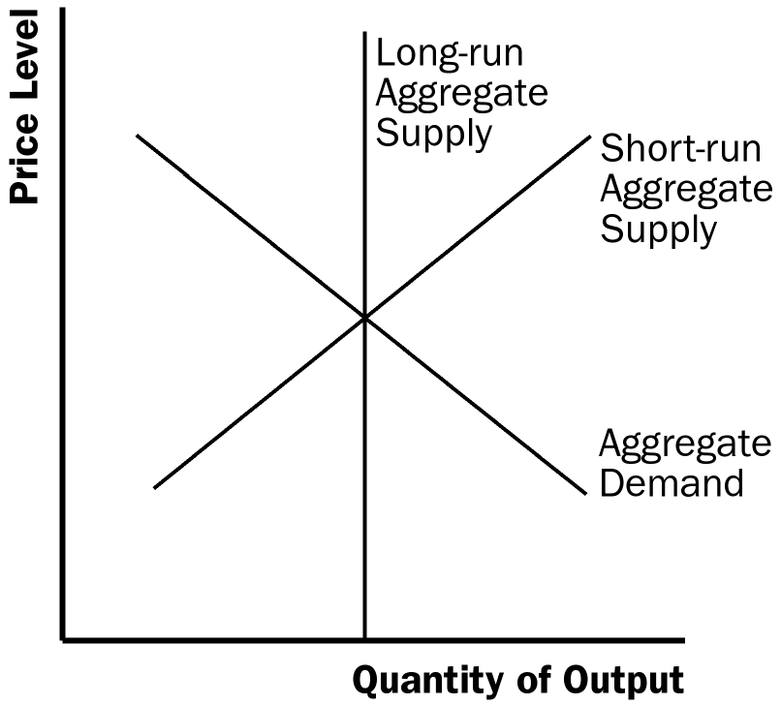

3. List and explain the three reasons the aggregate demand curve slopes downward.

The aggregate-demand curve slopes downward because:
(1) a decrease in the price level makes consumers feel wealthier, which in turn encourages them to spend more, so there is a larger quantity of goods and services demanded;
(2) a lower price level reduces the interest rate, encouraging greater spending on investment, so there is a larger quantity of goods and services demanded;
(3) a fall in the U.S. price level causes U.S. interest rates to fall, so the real exchange rate depreciates, stimulating U.S. net exports, so there is a larger quantity of goods and services demanded.

4. Explain why the long-run aggregate supply curve is vertical.

The long-run aggregate supply curve is vertical because in the long run, an economy's supply of goods and services depends on its supplies of capital, labor, and natural resources and on the available production technology used to turn these resources into goods and services. The price level does not affect these long-run determinants of real GDP.

6. What might shift the aggregate demand curve to the left? Use the model of aggregate demand and aggregate supply to trace through the short-run and long-run effects of such a shift on output and the price level.

The aggregate-demand curve might shift to the left when something (other than a rise in the price level) causes a reduction in consumption spending (such as a desire for increased saving), a reduction in investment spending (such as increased taxes on the returns to investment), decreased government spending (such as a cutback in defense spending), or reduced net exports (such as when foreign economies go into recession).

The figure below traces through the steps of such a shift in aggregate demand. The economy begins in equilibrium, with short-run aggregate supply, AS1, intersecting aggregate demand, AD1, at point A. When the aggregate-demand curve shifts left to AD2, the economy moves from point A to point B, reducing the price level and the quantity of output. Over time, people adjust their perceptions, wages, and prices, shifting the short-run aggregate-supply curve to the right to AS2, and moving the economy from point B to point C, which is back on the long-run aggregate-supply curve and has a lower price level.

