ECON 111 -01A & -02A Fall 2016
Intro to Economics Dr. John F. Olson
Answers to HWPS #2

Chapter 6, p. 130 -- from the Problems and Applications: #s 3 and 4

3. a. The equilibrium price of Frisbees is $8 and the equilibrium quantity is six million Frisbees.

b. With a price floor of $10, the new market price is $10 because the price floor is binding. At that price, only two million Frisbees are sold, because that is the quantity demanded.

c. If there’s a price ceiling of $9, it has no effect, because the market equilibrium price is $8, which is below the ceiling. So the market price is $8 and the quantity sold is six million Frisbees.

4. a. The figure on the left below shows the market for beer without the tax. The equilibrium price is P₁ and the equilibrium quantity is Q₁. The price paid by consumers is the same as the price received by producers, P₁.

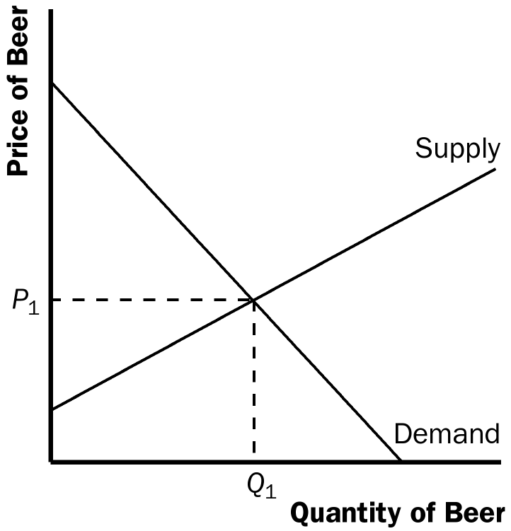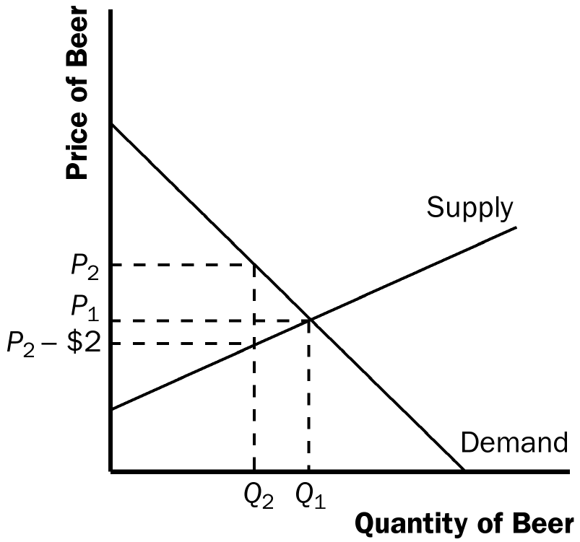

b. When the tax is imposed, it drives a wedge of $2 between supply and demand, as shown in the figure above on the right. The price paid by consumers is P₂, while the price received by producers is P₂ – $2. The difference between the price paid by consumers and the price received by producers is the $2 tax. The quantity of beer sold declines to Q₂.

Chapter 7, p. 151 -- from the Questions for Review: # 3

3. The figure below shows producer and consumer surplus in a supply-and-demand diagram. The producer surplus is the area below the equilibrium price and above the supply curve; the consumer surplus is the area below the demand curve and above the equilibrium price.

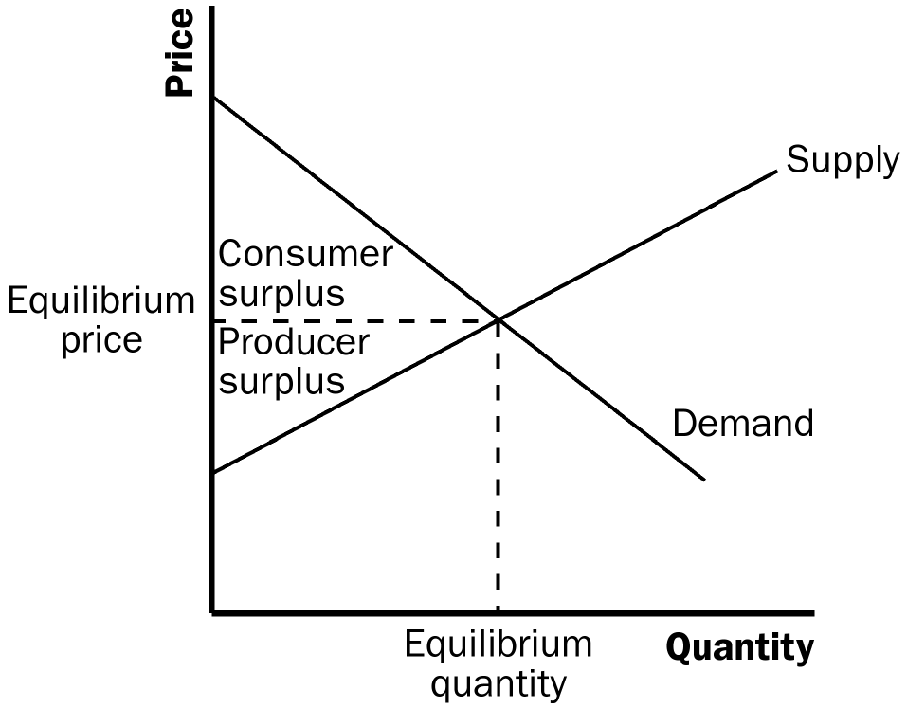

Chapter 8, p. 168 -- from the Questions for Review: #s 2 and 5

2. The figure below illustrates the deadweight loss and tax revenue from a tax on the sale of a good. Without a tax, the equilibrium quantity would be Q₁, the equilibrium price would be P₁, consumer surplus would be A + B + C, and producer surplus would be D + E + F.

The imposition of a tax places a wedge between the price buyers pay, P_{B}, and the price sellers receive, P_{S}, where P_{B} = P_{S} + tax. The quantity sold declines to Q₂. Now consumer surplus is A, producer surplus is F, and government revenue is B + D. The deadweight loss of the tax is C+E, because that area is lost due to the decline in quantity from Q₁ to Q₂.

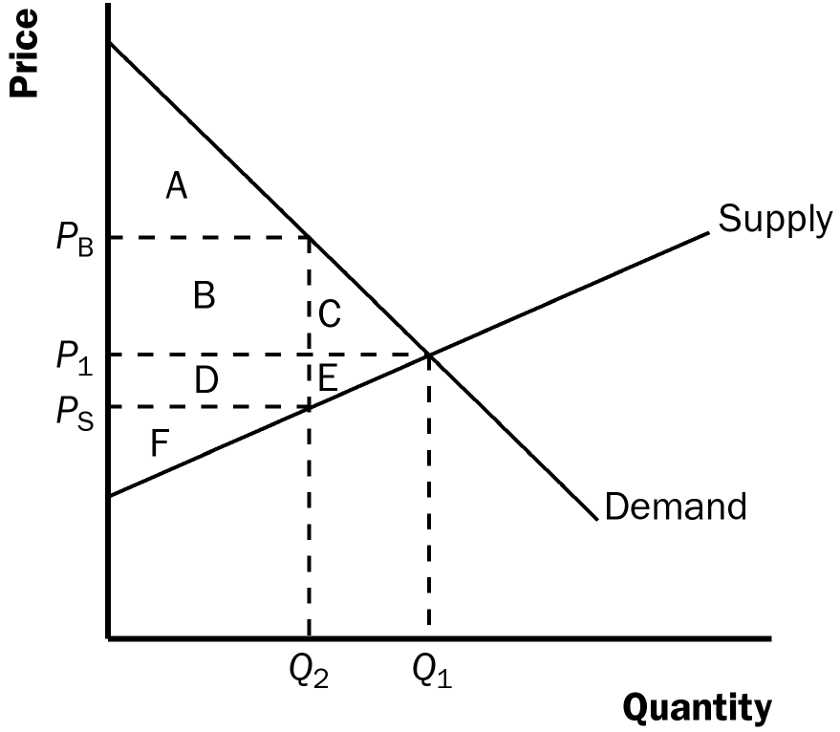

5. The deadweight loss of a tax rises more than proportionally as the tax rises. Tax revenue, however, may increase initially as a tax rises, but as the tax rises further, revenue eventually declines.

Chapter 9, p. 190 -- from the Problems and Applications: # 3

3. a. For a country that imports clothing, the effects of a decline in the world price are shown in the figure below. The initial price is P_{w1} and the initial level of imports is Q_{d1} – Q_{s1}. The new world price is P_{w2} and the new level of imports is Q_{d2} – Q_{s2}. The table below shows the changes in consumer surplus, producer surplus, and total surplus. Domestic consumers are made better off, while domestic producers are made worse off. Total surplus rises by areas D + E + F.

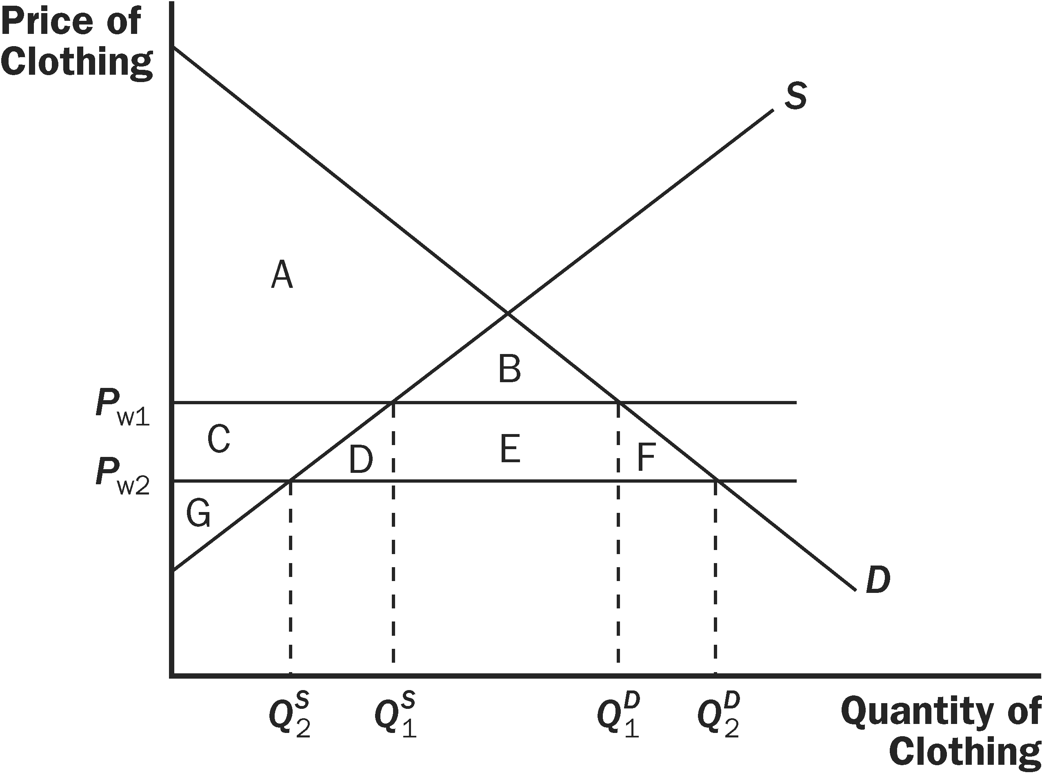

 | P_{w1} | P_{w2} | CHANGE
Consumer Surplus | A+B | A+B+C+D+E+F | C+D+E+F
Producer Surplus | C+G | G | –C
Total Surplus | A+C+G | A+B+C+D+E+F+G | D+E+F

b. For a country that exports clothing, the effects of a decline in the world price are shown in the figure below. The initial price is P_{w1} and the initial level of exports is Q_{s1} – Q_{d1}. The new world price is P_{w2} and the new level of exports is Q_{s2} – Q_{d2}. The table below shows the changes in consumer surplus, producer surplus, and total surplus. Domestic consumers are made better off, while domestic producers are made worse off. Total surplus falls by area D.

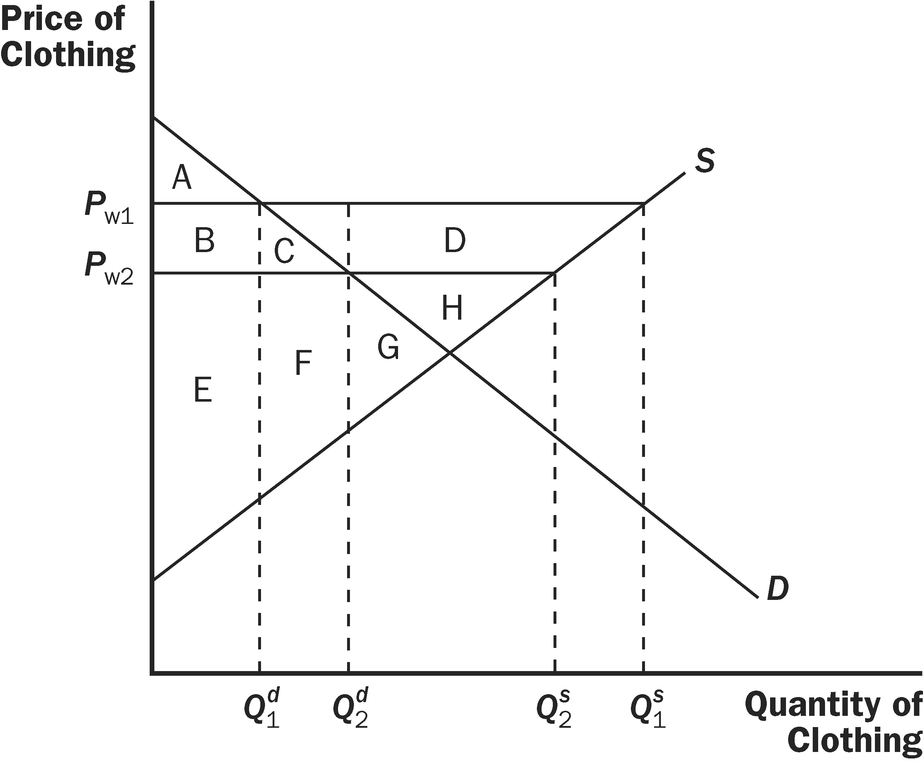

 | P_{w1} | P_{w2} | CHANGE
Consumer Surplus | A | A + B + C | B + C
Producer Surplus | B + C + D + E + F + G + H | E + F + G + H | –B – C – D
Total Surplus | A + B + C + D + E + F + G + H | A + B + C + E + F + G + H | –D

c. Overall, importing countries benefit from the fall in the world price of clothing, while exporting countries are harmed.

Chapter 12, pp. 252-253 -- from the Problems and Applications: #s 1, 3, 4, 9, and 10

1. a. opportunity cost d. variable cost
b. average total cost e. total cost
c. fixed cost f. marginal cost

3. a. The following table shows the marginal product of each hour spent fishing:

Hours Fish Marginal Product Fixed Cost Variable Cost Total Cost
0 0 -- $10 $ 0 $10
1 10 10 10 5 15
2 18 8 10 10 20
3 24 6 10 15 25
4 28 4 10 20 30
5 30 2 10 25 35

b. The graph below on the left shows the fisherman's production function. The production function becomes flatter as the number of hours spent fishing increases, illustrating diminishing marginal product.

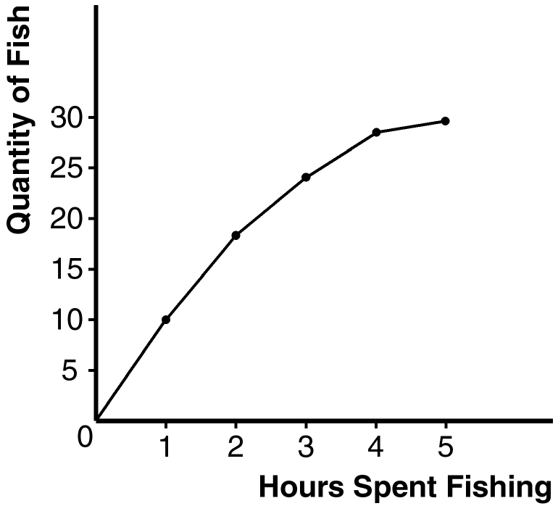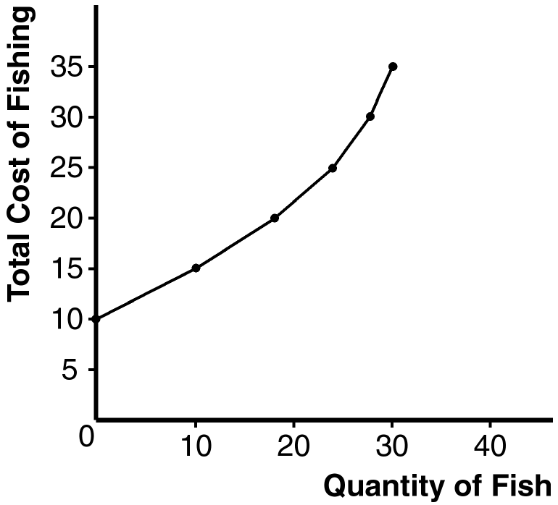

c. The table above (in a) shows the fixed cost, variable cost, and total cost of fishing. The graph above on the right shows the fisherman's total-cost curve. It has an upward slope because catching additional fish takes additional time. The curve is convex (curves upward) because there are diminishing returns to fishing time, which means that each additional hour spent fishing yields fewer additional fish.

4. Here is the completed table:

Workers Output Marginal Product Total Cost Average Total Cost Marginal Cost
0 0 --- $200 --- ---
1 20 20 300 $15.00 $ 5.00
2 50 30 400 8.00 3.33
3 90 40 500 5.56 2.50
4 120 30 600 5.00 3.33
5 140 20 700 5.00 5.00
6 150 10 800 5.33 10.00
7 155 5 900 5.81 20.00

a. See the table for marginal product. Marginal product rises at first, then declines because of diminishing marginal product.

b. See the table for total cost.

c. See the table for average total cost. Average total cost is U-shaped. When quantity is low, average total cost declines as quantity rises; when quantity is high, average total cost rises as quantity rises.

d. See the table for marginal cost. Marginal cost is also U-shaped, but rises steeply as output increases. This is due to diminishing marginal product.

e. When marginal product is rising, marginal cost is falling, and vice versa.

f. When marginal cost is less than average total cost, average total cost is falling; the cost of the last unit produced pulls the average down. When marginal cost is greater than average total cost, average total cost is rising; the cost of the last unit produced pushes the average up.

9. a. The table below shows average variable cost (AVC), average total cost (ATC), and marginal cost (MC) for each quantity.

Quantity Variable Cost Total Cost AVC ATC MC
0 $0.00 $30.00 --- --- ---
1 10.00 40.00 $10.00 $40.00 $10.00
2 25.00 55.00 12.50 27.50 15.00
3 45.00 75.00 15.00 25.00 20.00
4 70.00 100.00 17.50 25.00 25.00
5 100.00 130.00 20.00 26.00 30.00
6 135.00 165.00 22.50 27.50 35.00

b. The graph below shows the three curves. The marginal-cost curve is below the average-total-cost curve when output is less than four and average total cost is declining. The marginal-cost curve is above the average-total-cost curve when output is above four and average total cost is rising. The marginal-cost curve lies above the average-variable-cost curve.

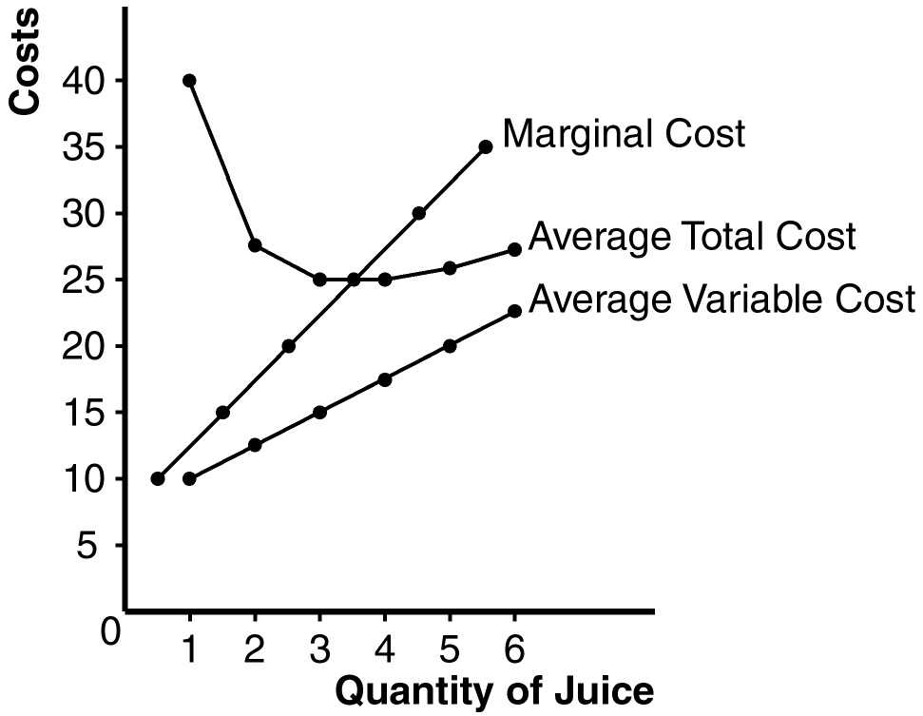

10. The table below shows quantity (Q), total cost (TC), and average total cost (ATC) for the three firms:

Firm A Firm B Firm C
Quantity TC ATC TC ATC TC ATC
1 $60.00 $60.00 $11.00 $11.00 $21.00 $21.00
2 70.00 35.00 24.00 12.00 34.00 17.00
3 80.00 26.67 39.00 13.00 49.00 16.33
4 90.00 22.50 56.00 14.00 66.00 16.50
5 100.00 20.00 75.00 15.00 85.00 17.00
6 110.00 18.33 96.00 16.00 106.00 17.67
7 120.00 17.14 119.00 17.00 129.00 18.43

Firm A has economies of scale because average total cost declines as output increases. Firm B has diseconomies of scale because average total cost rises as output rises. Firm C has economies of scale from one to three units of output and diseconomies of scale for levels of output beyond three units.

