ECON 111-01A Dr. John F. Olson
Introduction to Economics Fall 2015
Homework Problem Set #3 -- Answers

The assignment was to prepare written responses to the Problems and Applications on pp. 252-3 in the Mankiw text -- #s 1, 3, 4, 9, & 10.

1. a. opportunity cost d. variable cost
b. average total cost e. total cost
c. fixed cost f. marginal cost

3. a. The following table shows the marginal product of each hour spent fishing:

Hours Fish Marginal Product Fixed Cost Variable Cost Total Cost
0 0 -- $10 $ 0 $10
1 10 10 10 5 15
2 18 8 10 10 20
3 24 6 10 15 25
4 28 4 10 20 30
5 30 2 10 25 35

b. The graph below on the left shows the fisherman's production function. The production function becomes flatter as the number of hours spent fishing increases, illustrating diminishing marginal product.

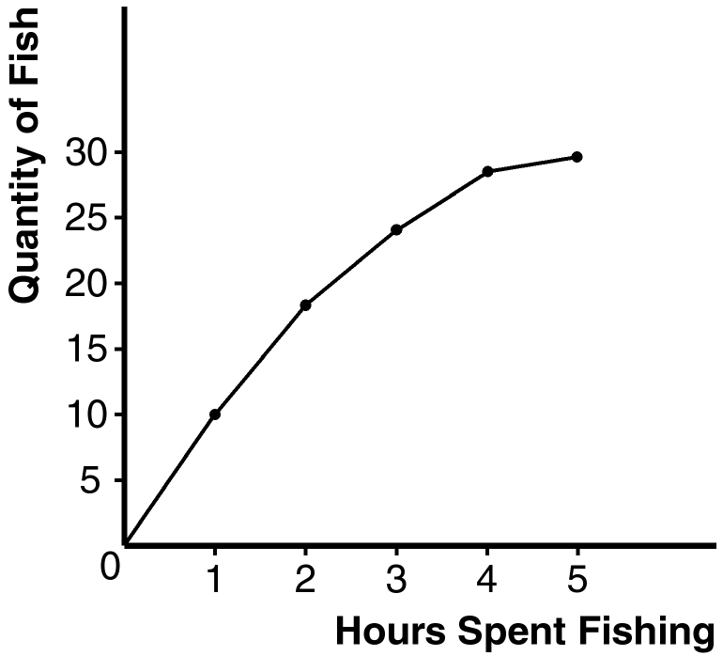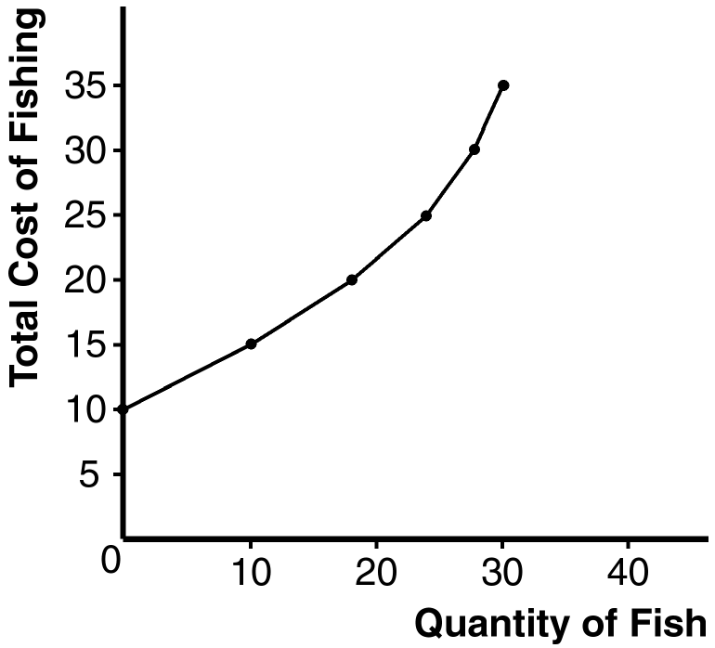

c. The table above (in a) shows the fixed cost, variable cost, and total cost of fishing. The graph above on the right shows the fisherman's total-cost curve. It has an upward slope because catching additional fish takes additional time. The curve is convex (curves upward) because there are diminishing returns to fishing time, which means that each additional hour spent fishing yields fewer additional fish.

4. Here is the completed table:

Workers Output Marginal Product Total Cost Average Total Cost Marginal Cost
0 0 --- $200 --- ---
1 20 20 300 $15.00 $ 5.00
2 50 30 400 8.00 3.33
3 90 40 500 5.56 2.50
4 120 30 600 5.00 3.33
5 140 20 700 5.00 5.00
6 150 10 800 5.33 10.00
7 155 5 900 5.81 20.00

a. See the table for marginal product. Marginal product rises at first, then declines because of diminishing marginal product.

b. See the table for total cost.

c. See the table for average total cost. Average total cost is U-shaped. When quantity is low, average total cost declines as quantity rises; when quantity is high, average total cost rises as quantity rises.

d. See the table for marginal cost. Marginal cost is also U-shaped, but rises steeply as output increases. This is due to diminishing marginal product.

e. When marginal product is rising, marginal cost is falling, and vice versa.

f. When marginal cost is less than average total cost, average total cost is falling; the cost of the last unit produced pulls the average down. When marginal cost is greater than average total cost, average total cost is rising; the cost of the last unit produced pushes the average up.

9. a. The table below shows average variable cost (AVC), average total cost (ATC), and marginal cost (MC) for each quantity.

Quantity Variable Cost Total Cost AVC ATC MC
0 $0.00 $30.00 --- --- ---
1 10.00 40.00 $10.00 $40.00 $10.00
2 25.00 55.00 12.50 27.50 15.00
3 45.00 75.00 15.00 25.00 20.00
4 70.00 100.00 17.50 25.00 25.00
5 100.00 130.00 20.00 26.00 30.00
6 135.00 165.00 22.50 27.50 35.00

b. The graph below shows the three curves. The marginal-cost curve is below the average-total-cost curve when output is less than four and average total cost is declining. The marginal-cost curve is above the average-total-cost curve when output is above four and average total cost is rising. The marginal-cost curve lies above the average-variable-cost curve.

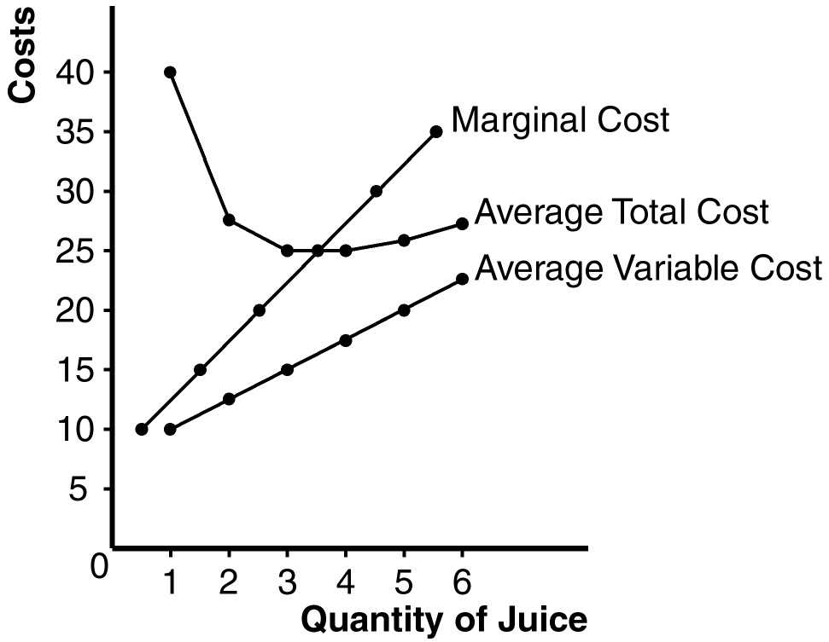

10. The table below shows quantity (Q), total cost (TC), and average total cost (ATC) for the three firms:

Firm A Firm B Firm C
Quantity TC ATC TC ATC TC ATC
1 $60.00 $60.00 $11.00 $11.00 $21.00 $21.00
2 70.00 35.00 24.00 12.00 34.00 17.00
3 80.00 26.67 39.00 13.00 49.00 16.33
4 90.00 22.50 56.00 14.00 66.00 16.50
5 100.00 20.00 75.00 15.00 85.00 17.00
6 110.00 18.33 96.00 16.00 106.00 17.67
7 120.00 17.14 119.00 17.00 129.00 18.43

Firm A has economies of scale because average total cost declines as output increases. Firm B has diseconomies of scale because average total cost rises as output rises. Firm C has economies of scale from one to three units of output and diseconomies of scale for levels of output beyond three units.

