ECON 111 -01A & -02A Prof. John F. Olson
HWPS #2 answers Fall 2014

Questions/Problems:

1. What is the difference between a “change in demand” and a “change in quantity demanded”? How are these each presented or shown in a graph of a demand curve? Similarly, what is the difference between a “change in supply” and a “change in quantity supplied”? How are these each presented or shown in a graph of a supply curve?

A “change in demand” refers to a shift of the demand curve, while a “change in quantity demanded” refers to a movement along a given demand curve. A demand curve (or schedule) displays the various quantities demanded at different prices, holding other things constant (ceteris paribus) such as income, the number of buyers in the market, the prices of related goods, and other non-price factors or variables that affect demand. A “change in demand” shifts the demand curve (or schedule) when any of those non-price factors or variables change, affecting the buyers’ behavior. When those non-price factors or variables are held constant and the price of the good or service changes, then there will be a “change in quantity demanded” with a movement along the demand curve.

The same reasoning/explanation holds for supply. A “change in supply” refers to a shift of the supply curve due to changes in non-price factors or variables affecting sellers’ behavior, while a “change in quantity supplied” is a movement along the supply curve as the price changes, holding other things constant.

2. Consider the demand curve for hamburgers sold in local area food establishments (restaurants, bars & grills, fast-food outlets, etc.). For each of the following events, what happens to that demand curve and briefly explain why:
a. the price of tacos sold in local area food establishments decreases
The demand for hamburgers decreases (shifts left) because tacos are a substitute for hamburgers; with a lower price of tacos, people would eat more tacos and fewer hamburgers.
b. the price of french fries sold in local area food establishments increases
The demand for hamburgers decreases (shifts left) because French fries are complements to hamburgers; with french fries more expensive, people would eat less of them and, accordingly, fewer hamburgers with them.
c. if hamburgers are an income-normal good, incomes in the local area rise in an economic recovery
In this case, the demand for hamburgers increases (shifts right) as income rises.
d. if hamburgers are an income-inferior good, incomes in the local area fall in an economic recession
In this case, the demand for hamburgers increases (shifts right) as incomes fall.
e. local health officials report that they have found some samples of area beef products are contaminated with illness-causing e. coli bacteria
The demand for hamburgers would decrease (shift left); such a report would reduce hamburger buyers’ “tastes and preferences” (they want to avoid illness and possible death).
f. reports about regional drought conditions suggest prices of beef products will rise later in the year
There a couple of different possible responses. First, some consumers might, in anticipation of the higher expected hamburger prices in the future, increase their current demand for (and consumption of) hamburgers – that is, expecting/knowing that they might reduce future consumption, they might eat more hamburgers now. Second, other consumers might not change their current demand and consumption (how many hamburgers can one at a meal or how many times a week?); that is, the increase in expected future prices of hamburgers would not have much, if any, effect on the current demand.
3. Now consider the supply curve for hamburgers sold in local area food establishments (restaurants, bars & grills, fast-food outlets, etc.). For each of the following events, what happens to that supply curve and briefly explain why:
a. the price of hamburger buns decreases
The supply of hamburgers increases (shifts right) because hamburgers are sold with/on buns.
b. wages paid to food establishment workers increase
The supply of hamburgers decreases (shifts left) because of higher labor (input) costs.
c. the price of hot dogs decreases
The supply of hamburgers increases (shifts right). Hot dogs are an alternative to producing and selling hamburgers for these food establishments; the lower price makes selling hot dogs less attractive to selling hamburgers.
d. reports about regional drought conditions suggest prices of beef products will rise later in the year
There could be two possible effects. First, the food establishments could leave their current supply of hamburgers unchanged, while increasing their purchases beef products and storing them in advance of the expected price increases. Second, they could reduce their current supply of hamburgers (shifting the supply curve left) and store/freeze the hamburgers for future sale.

4. Consider the market for minivans. For each of the following events listed below, identify which of the determinants of demand or supply are affected. Also indicate whether demand or supply increases or decreases. Then draw a diagram to show the effect on the equilibrium price and quantity of minivans.
a. people decide to have more children
This increases the number of buyers of minivans, so the demand increases (shifts to the right). No change in the supply curve. The equilibrium price and quantity both increase.

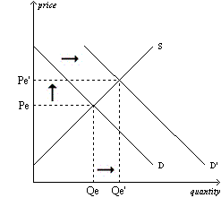
b. a strike by steelworkers raises steel prices
This increases the input costs of producing minivans, so the supply decreases (shifts to the left). No change in the demand curve. The equilibrium price rises and the equilibrium quantity decreases.
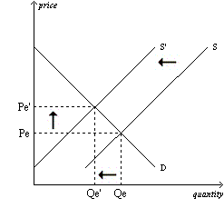

c. engineers develop new automated machinery for the production of minivans
This is an improvement in technology which increases the supply (shifts to the right). No change in the demand curve. The equilibrium price decreases and the equilibrium quantity increases.

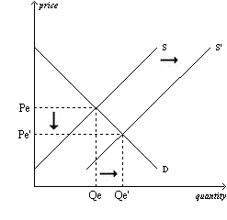
d. the price of sports utility vehicles rises
If sports utility vehicles are substitutes for minivans, then this is an increase in the price of a substitute good, and the demand for minivans increases, which increases the equilibrium price and quantity of minivans. The increase price of sports utility vehicles could induce firms to increase production of sport utility vehicles and reduce their production (supply) of minivans – shifting the supply of minivans to the left – which would increase the equilibrium price and reduce the equilibrium quantity of minivans.
Or one could combine the two graphs – in the case of demand increasing and supply decreasing, the equilibrium price will unambiguously increase, while the change in equilibrium quantity will be ambiguous (either slightly increasing, decreasing, or staying the same).

e. a stock market crash lowers people’s wealth
With the stock market lowering people’s wealth, this decreases the demand for minivans (shifts to the left). With no change in the supply curve, the equilibrium price and quantity both decrease.

5. Consider the market for coffee beans as shown in the demand and supply graph below.
a. what are the equilibrium price and quantity?
The supply and demand curves intersect at a price of $1.00 and 10 (billions of pounds); that is, at that price, the quantity demanded equals the quantity supplied.
b. suppose the market price was $1.50 per pound; what condition would exist in the market? What would happen to the market price in this situation?
At that price, the quantity demanded is less than the quantity supplied – there would be an excess supply or a surplus. In such circumstances, the price would fall.
c. suppose the market price was $0.75 per pound; what condition would exist in the market? What would happen to the market price in this situation?
At that price, the quantity demanded is more than the quantity supplied – there would be an excess demand or a shortage. In such circumstances, the price would rise.

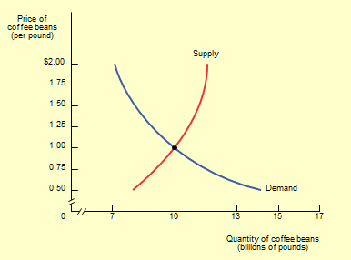

6. Consider this data on the demand and supply schedules for the lobster market:

Price of Lobster Quantity of Lobster Quantity of Lobster New Quantity
(per pound) Demanded (pounds) Supplied (pounds) Demanded (lbs.)
$35 200 1400 600
30 400 1200 800
25 600 1000 1000
20 800 800 1200
15 1000 600 1400
10 1200 400 1600
5 1400 200 1800

- Construct a well-labeled graph, plotting the demand and supply curves.

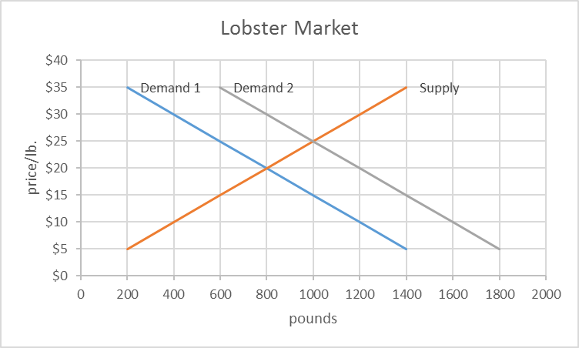

b. What are the equilibrium price and quantity, verifying the results are identical in the schedules and graph?
The equilibrium price is $20 and quantity is 800 pounds. This can be verified in the table above (Q^{s}=Q^{d}=800 pounds at $10) and in the graph where the demand and supply curves intersect at those values.
c. Now suppose that incomes rise (lobster is an income-normal good) and the demand for lobster increases by 400 pounds at each price. Plot and label the new demand curve on your original graph. What is the new equilibrium price and quantity?
With the demand schedule/curve shifted to the right by 400 pounds, the new equilibrium price is $25 and quantity is 1000 pounds.

7. The small town of Middling experiences a sudden doubling of the birth rate. After three years, the birth rate returns to normal. Illustrate the effect of these events on the following:
a. the market for an hour of babysitting services in Middling today
During (and for a few years after) the period of the higher birth rate, the demand for babysitting services will increase – more babies and kids to be babysat – the demand curve shifts to the right. The price for (cost of) babysitters is likely to increase.

b. the market for an hour of babysitting services 14 years into the future, after the birth rate has returned to normal, by which time children born today are old enough to work as babysitters
When this larger cohort of children reaches their early teens and can work as babysitters, this will increase the supply of babysitters (the supply curve shifts right). Given that the demand curve will have returned to its original normal level (pre-baby boom), the price for (cost of) babysitters is likely to decrease.

8. Suppose that the demand curve for a good is expressed as Q^{D} = 1600 – 300*P and the supply curve as Q^{S} = 1400 + 700*P.

- Find the algebraic numerical solution for P where Q^{D} = Q^{S}. At that value of P, show that Q^{D} is numerically equal to Q^{S}.
With the demand curve as Q^{D} = 1600 – 300*P and the supply curve as Q^{S} = 1400 + 700*P, we have two equations with two unknowns (P and Q). In equilibrium, Q^{D} = Q^{S}, so we can substitute. We then have 1600 – 300*P = 1400 + 700*P. Solving for P, we find P = $0.20. Substituting that into each of the demand and supply equations, Q^{D} and Q^{S} are each equal to 1540.

b. For values of P from $0.05 to $0.30 in 5-cent increments, prepare a table showing the demand and supply schedules. Then graph the demand and supply curves. Verify that your answers in “a” are also the same as those shown your table and in the graph.

P Q^{D} Q^{S}
$ 0.05 1585 1435
0.10 1570 1470
0.15 1555 1505
0.20 1540 1540
0.25 1525 1575
0.30 1510 1610

