ECON 111-01A & -02A Fall 2014
Introduction to Economics Dr. John F. Olson
Answers to HWPS #1

Chapter 2 – Questions for Review (p. 35)

#2 – Economists make assumptions to simplify problems without substantially affecting the answer. Assumptions can make the complex world easier to understand.

#6 – The figure below shows a production possibilities frontier between milk and cookies (PPF1).
If a disease kills half of the economy's cow population, less milk production is possible, so the PPF shifts inward (PPF2). Note that if the economy produces all cookies, it does not need any cows and production is unaffected. But if the economy produces any milk at all, then there will be less production possible after the disease hits.

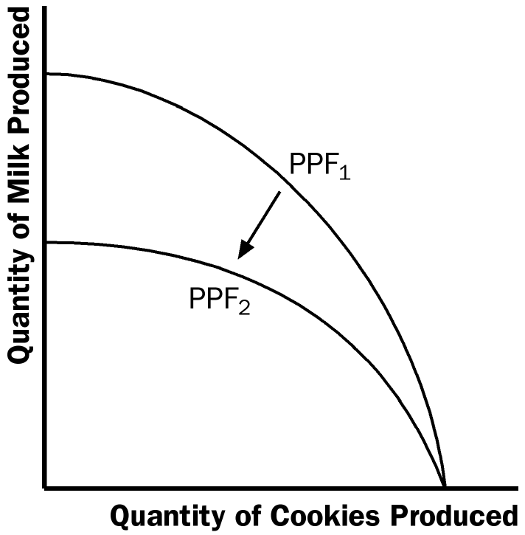

Chapter 2 – Problems and Applications (p. 36)

#5 – a. a family's decision about how much income to save is related to microeconomics.
b. the effect of government regulations on auto emissions is related to microeconomics.
c. the impact of higher saving on economic growth is related to macroeconomics.
d. a firm's decision about how many workers to hire is related to microeconomics.
e. the relationship between the inflation rate and changes in the quantity of money is related to macroeconomics.

#6 – a. positive; the statement deals with how the economy is (and not an opinion of how it should be); economists have examined data and found that there is a short-run negative relationship between inflation and unemployment, so the statement is a fact.
b. positive; the statement deals with how the economy is (and not an opinion of how it should be); economists have found that money growth and inflation are very closely-related (most of the time), so the statement is a fact.
c. normative; the statement is an opinion about something that should be done, not how the world is.
d. normative; the statement is an opinion about something that should be done, not how the world is.
e. positive; the statement deals with how the economy is (and not an opinion of how it should be); economists have studied the relationship between tax rates and work and saving, finding a negative (but small) relationship in both cases, so the statement is a fact.
Chapter 3 – Questions for Review (p. 59)

#1 – The production possibilities frontier will be linear if the opportunity cost of producing a good is constant no matter how much of that good is produced. That is, if each unit of the resources used to produce the goods are identical in their productivity, then the PPF will be linear (a straight line).

Correspondingly, if the resource units are not of identical productivity, the PPF will be bowed-out (concave to the graph’s origin) – reflecting increasing opportunity cost of producing more of a good.

#5 – In order for trade to benefit both parties, the price for the trade must lie between the parties’ opportunity costs.

#6 – Economists oppose policies that restrict trade among nations because trade allows all countries to achieve greater prosperity through the gains from comparative advantage. Restrictions on trade can hurt all countries.

Chapter 3 – Problems and Applications (p.60)

#2 – a.
 | Workers needed to make:
 | One Car | One Ton of Grain
U.S. | 1/4 | 1/10
Japan | 1/4 | 1/5

b. See the figure below. With 100 million workers and 4 cars per worker, if either economy were devoted completely to cars, it could make 400 million cars. Because a U.S. worker can produce 10 tons of grain, if the U.S. produced only grain it would produce 1,000 million tons. Because a Japanese worker can produce 5 tons of grain, if Japan produced only grain it would produce 500 million tons. These are the intercepts of the two PPFs shown below. Note that because the trade-off between cars and grain is constant for both countries, the two PPFs are straight lines (linear).

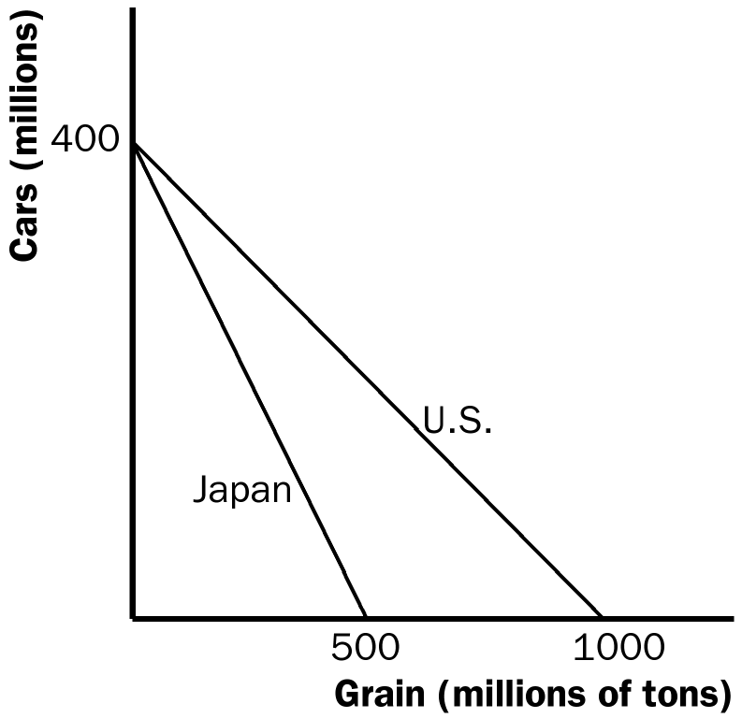

c. In the U.S., the opportunity cost of one car is 10/4 or 2.5 tons of grain, while the opportunity cost of a ton grain is 2/5 or 0.4 car.

In Japan, the opportunity cost of one car is 5/4 or 1.25 tons of grain, while the opportunity cost of a ton of grain is 4/5 or 0.8 car.

This results in the following table:

 | Opportunity Cost of:
 | One Car (in terms of tons of grain given up) | One Ton of Grain (in terms of cars given up)
U.S. | 10/4 or 2.5 | 4/10 or 0.4
Japan | 5/4 or 1.25 | 4/5 or 0.8

d. Neither country has an absolute advantage in producing cars, because they are equally productive (the same output per worker). The United States has an absolute advantage in producing grain, because it is more productive (greater output per worker).

e. Japan has a comparative advantage in producing cars because it has a lower opportunity cost in terms of grain given up. The U.S. has a comparative advantage in producing grain because it has a lower opportunity cost in terms of cars given up.

f. With half the workers in each country producing each of the two goods, the U.S. produces 200 million cars (50 million workers x 4 cars each) and 500 million tons of grain (50 million workers x 10 tons each), while Japan produces 200 million cars (50 million workers x 4 cars each) and 250 million tons of grain (50 million workers x 5 tons each).

g. From any situation with no trade, in which each country is producing some cars and some grain, suppose the U.S. shifted one worker from producing cars to producing grain; that worker would decrease car production by 4 and increase grain production by 10 tons. Then suppose the U.S. offers to trade some of this grain (any amount between 5 and 10 tons) to Japan for 4 cars. By trading, the U.S. can gain 4 cars from Japan at a lower (opportunity) cost than producing the cars domestically (at a cost of 10 tons of grain). Similarly, suppose Japan shifted one worker from producing grain to producing cars; that worker would decrease grain production by 5 tons and increase car production by 4. By trading those 4 cars to the U.S. (for an amount of grain between 5 and 10 tons), Japan gets more grain than they decreased domestic production to produce those 4 cars.

With the shift of workers and production (towards their lower opportunity cost good) and then trading, each country gets the same amount of cars as before and both get some additional grain. Thus, by changing their production and trading, both countries are better off.

